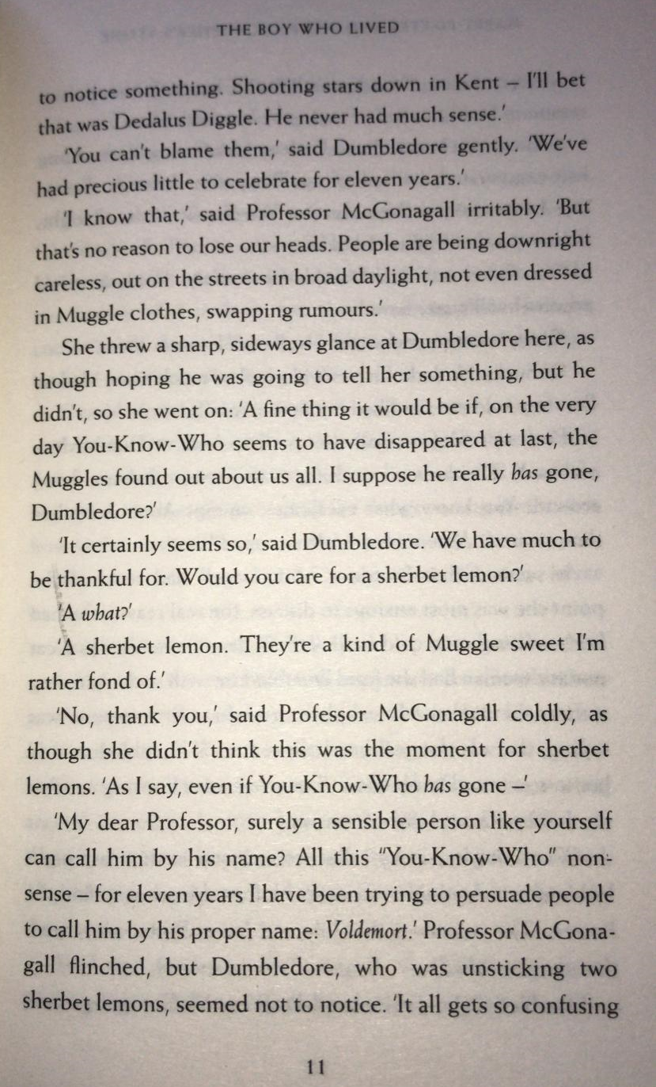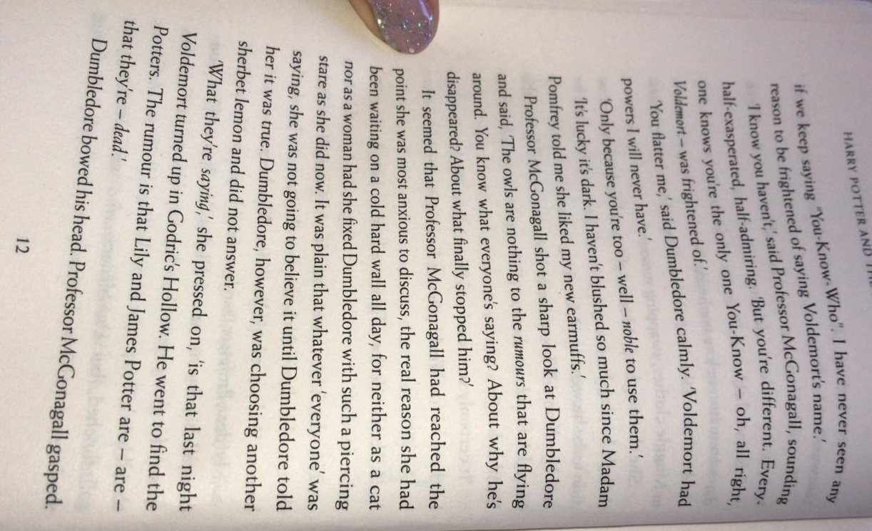
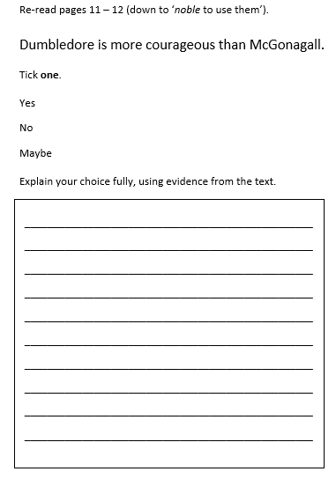
Write three ways in which people have been careless.
- ________________________________________
- ________________________________________
- ________________________________________
Circle the correct option.
How long has Dumbledore been suggesting people stop saying ‘You-Know-Who?

Eleven years |  | All day | Since Harry was born | Six months

Find and copy the verb that suggests McGonagall is fearful of Voldemort.
_______________________________________

‘Dumbledore bowed his head. Professor McGonagall gasped’.
What can the reader infer from the two characters’ body language?
Think about what they have been discussing just before they act in this way.

_______________________________________________________________

______________________________________________________________

_______________________________________________________________

_______________________________________________________________

