Wednesday 22nd April 2020
Maths

Mental Maths
6. 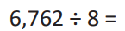

7. 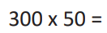

8. 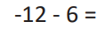

9.

10. Find the time difference between 07:34 and 12:19

- 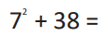

- 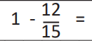 Think about what 1 whole would
be in fifteenths.

- 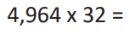

- 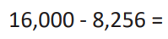

Main Activity

- Mr O’Brien wants to replace the school’s footballs. Each football costs £9 and he wants to order 134. How much will they cost?

- Miss Huntley needs to order some new whiteboard pens. She orders 16 boxes. Each box contains 240 pens. How many pens are ordered?

- Brandon goes to watch the football 17 times in a month. How many times does he watch the football over 12 months?

- Lewis takes a train to London. Each train carriage can carry 270 passengers. The train has 12 carriages. What is the total number of passengers that the train can carry?

- 2) If Riley eats 15 biscuits a day, how many does he eat over 234 days?

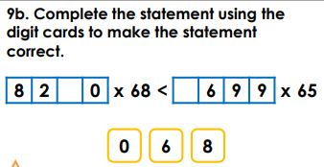
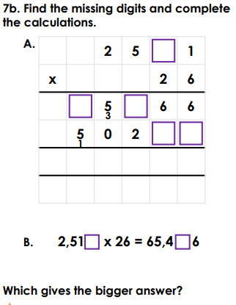
Challenge 1 Challenge 2

