Time Travelling with a Hamster
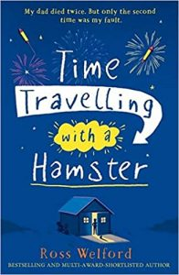
pg. 58 – 61

- Summarise chapter 10. What new things did we find out?

- Why do you think Mum is so adamant that Al makes friends?

