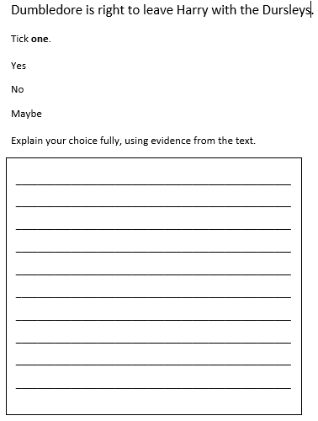
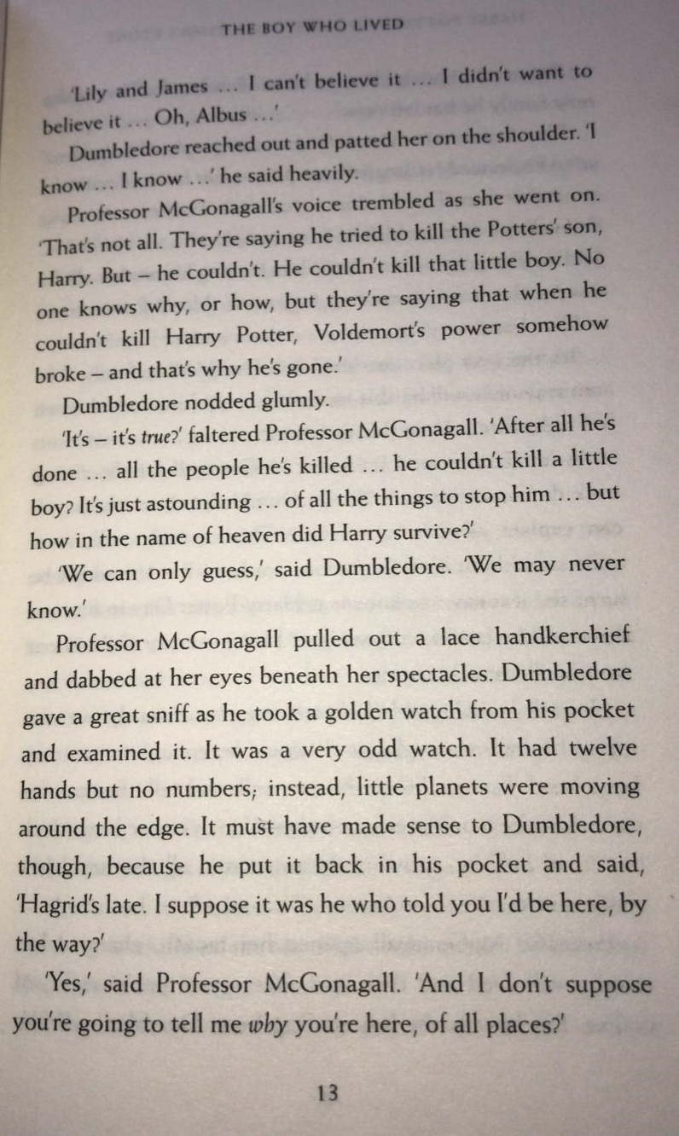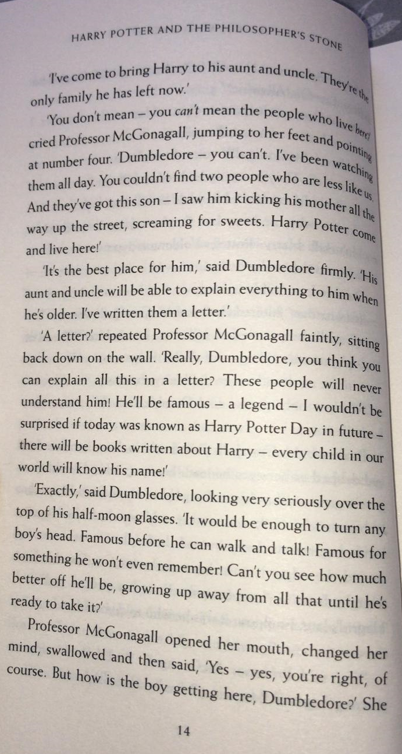
1. Write two ways readers know Professor McGonagall was upset on p.13.

- ______________________________________________

- ______________________________________________

- Write one way that Dumbledore’s watch was the same as an
ordinary watch, and one way that it was different.

- What does Professor McGonagall predict Harry will become?

- What made Professor McGonagall change her mind?

