Week 3 Monday English – Prefixes
Watch the video about how to use pre-fixes. Then complete the questions below.
https://www.theschoolrun.com/what-is-a-prefix
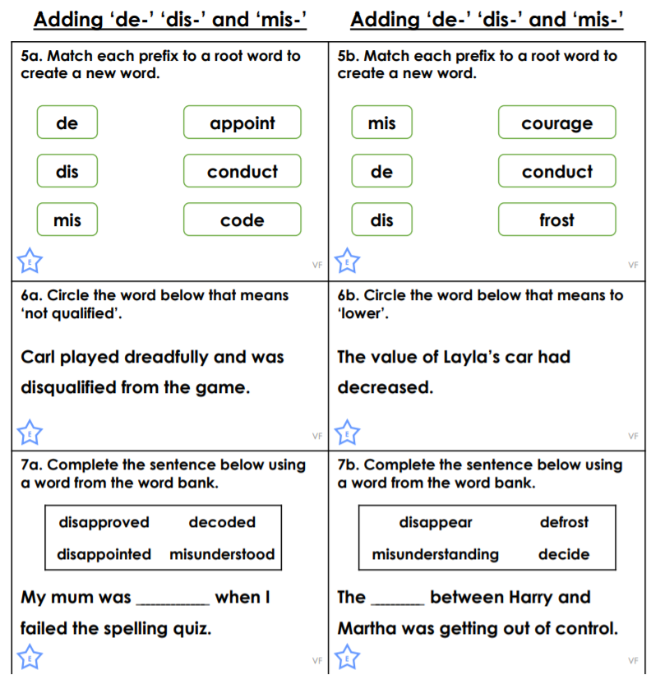

Then complete the challenge if you want to – Pie Corbett’s prefix game.

