Anglo-Saxon Britain
What happened to Britain when the Anglo-saxons came?
The Anglo-Saxons raided Britain in the year 450. Britian became divided into different kingdoms.
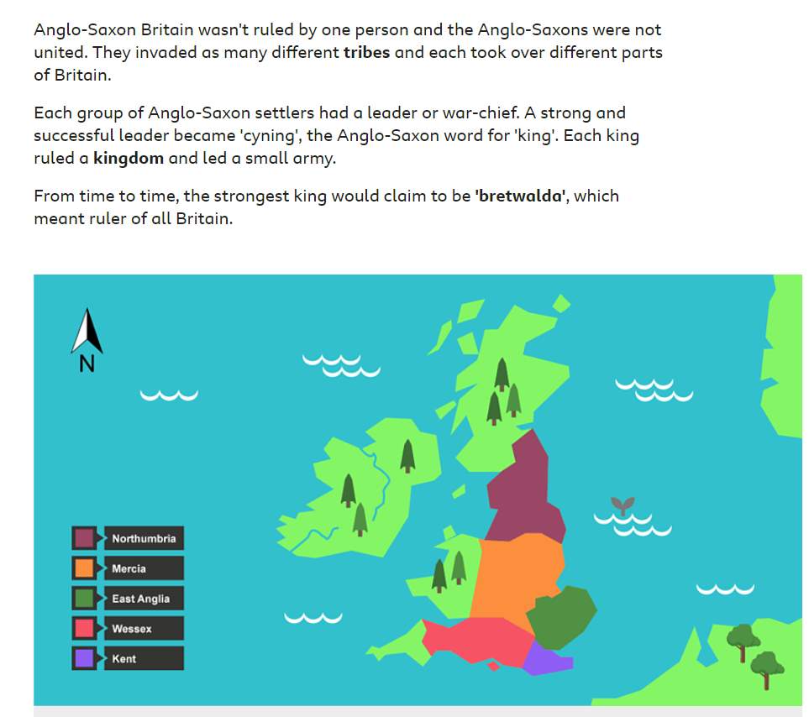

Create your own map of Britain and label the different Anglo-Saxon kingdoms.
You could draw it or make a model of it.
