Week 7 Day 1
https://www.bbc.co.uk/bitesize/articles/zbkbgwx
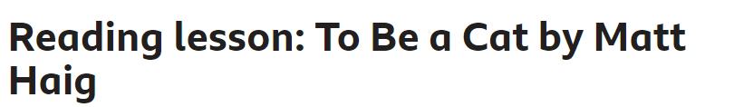
Matt Haig uses a lot of dialogue (direct speech where a character is talking) within this extract. Watch the extract read by Maro Itoje. Whilst watching, think about what job the dialogue is doing.
Is the dialogue:
- telling us more about a character?
- moving the story on?

