Week 7 Day 3 Wild Cat
Use some of these phrases to help explain your point.
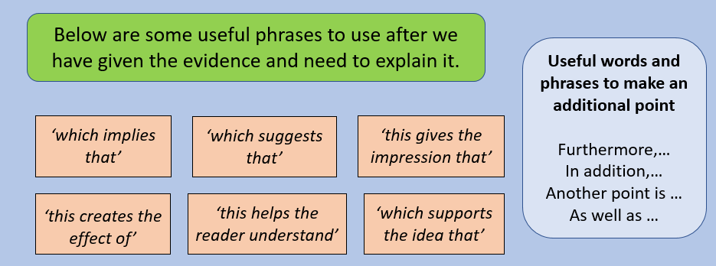
Use the checklist below to help you include all of the points you need to include for a 3 mark question.
