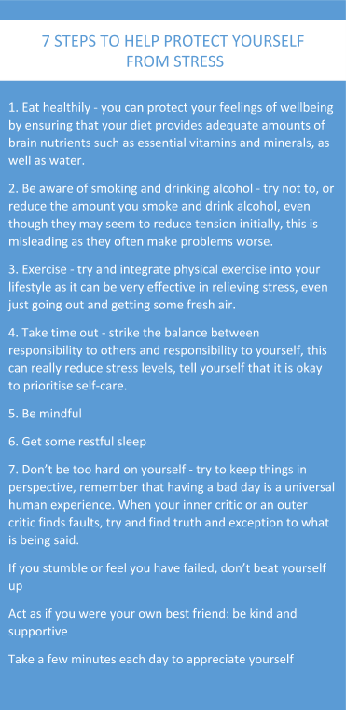
What is Wellbeing?
Hi everyone, we hope that you and all your families are staying well and safe. We send much love to all. Welcome to our school newsletter focused around your wellbeing during this challenging time.

Wellbeing can be defined as a complex combination of a person's physical, mental, emotional and social health. It includes having good mental health, high life satisfaction, a sense of meaning or purpose, and ability to manage stress. More generally, well-being is just feeling well. Well-being is something sought by just about everyone, because it includes so many positive things — feeling happy, healthy, socially connected, and purposeful.
How to keep that relaxed feeling in difficult times
1. Reconnect to your purpose - try to do one thing each week that reminds you why you became a teacher in the first place.
2. Create clear boundaries between home and school - set a reasonable time for school work (and stick to it). Find ways to turn off your teacher mind-set, so that you can relax.
3. Establish good sleeping habits – good quality sleep is one of the most important aspects of maintaining your physical and psychological health.
4. Keep focused on your goals - setting goals is a great way to give you direction, focus and motivation. Try to ensure that all your goals are achievable.
5. Reward yourself – the improved physical and psychological health that comes from prioritising your wellbeing is a reward in itself, but there’s value in using tangible rewards when you meet particular goals.

Have a look at some suggestions for daily wellbeing ideas. There are plenty I would like to try.
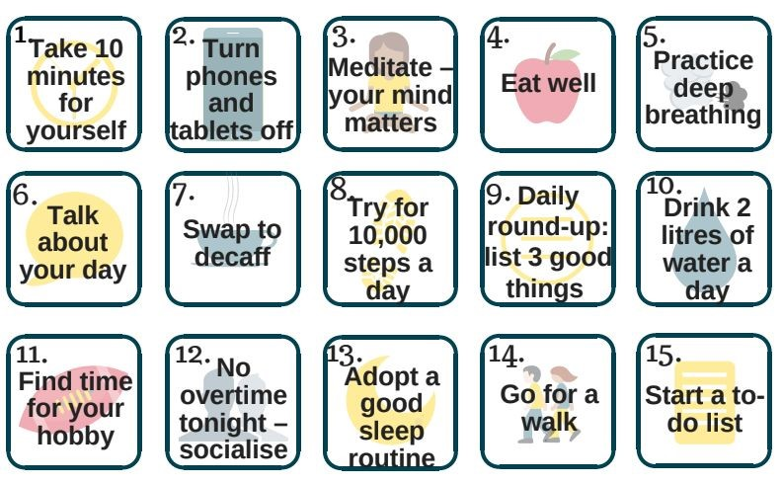
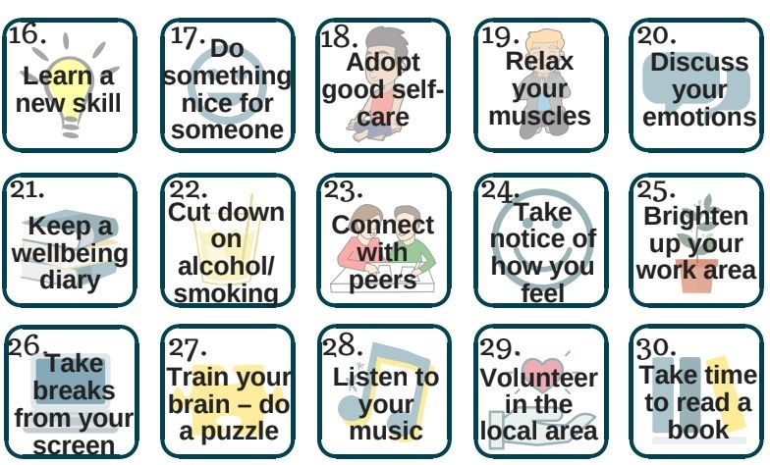

Every Newsletter we will be asking a member of staff some questions about what they’ve been up to and how they’ve been keeping positive. We asked Chris Tolson………….
How are you managing to keep in contact with loved ones who you can’t see at the moment?
Well, I am visiting my mum and dad but talking from a distance. I also take them shopping and talk to them daily. I am also trying to text friends and people I have not spoken to for a while too.
What have you been doing to relax at the moment?
I have been running 3 times a week which has been great as I live near the moors so the sunsets have been amazing. I have also been having a daily walk, gardening and spending time with the family.

What has been your favourite recipe to cook this week?
This is tricky but I tried the chocolate Cadburys creme egg recipe Miss Rosenberg recommended and it was delicious. Lily and I made it and it was great fun.
What are you reading?
I have just finished reading a book Mr Brownsell bought me about Jurgen Klopp. It was a great book and one I really enjoyed.
What is keeping you smiling?
At the moment I am feeling thankful to be with my family and I am overwhelmed with pride to see how our staff, children and families have responded to the challenges we are facing. It is such a privilege to work with so many amazing people.
What are you missing the most at the moment?
I am missing seeing the children every day and working with the most amazing staff team. We know we have to do it to keep people safe and I look forward to the day when we can all come together as a school once again- a whole school trip to Filey perhaps!
Any advice or messages you would like to give to your friends and colleagues?
Yes, remember you are all doing the best you can for school and I am so grateful for everything you have done and are doing. Look after yourself and spend time with those closest to you- cherish every second and find reasons to laugh and enjoy your daily fresh air -it makes such a difference.

Wellbeing websites and blogs
We have a team of mental health support workers in school: - Rebecca Oxley, Suzanne Louch, and Becky Albentosa. If you need help or support in any way, please reach out.
Below are some links to sites which offer advice and guidance.
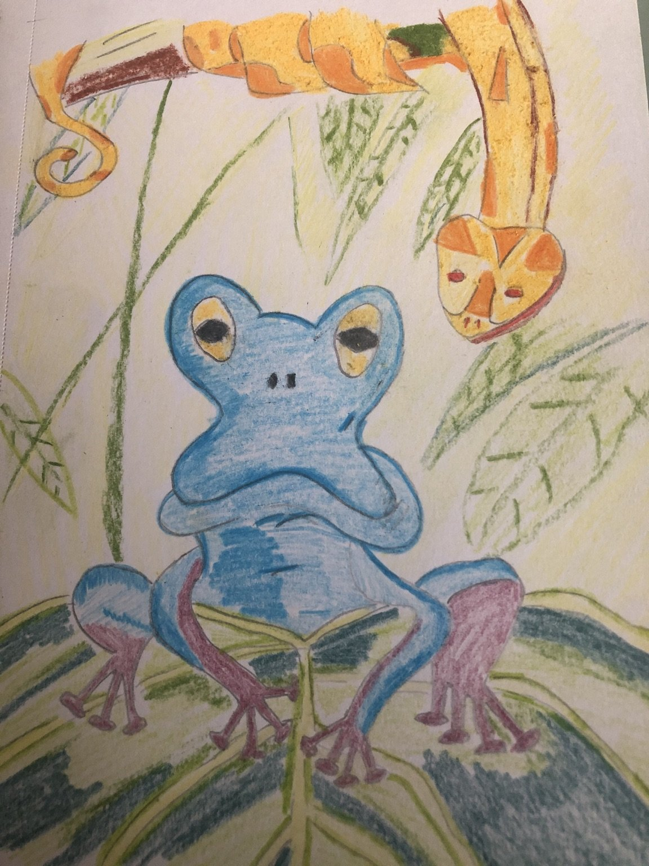
Mrs Guest’s great drawing!
https://www.gov.uk/government/news/new
-advice-to-support-mental-health-during-c oronavirus- outbreak
24/7 Confidential Counselling helpline,​through the Zurich Municipal, which can be reached on 0117 934 2121.​

Here are some of the wonderful things staff have been doing over the last few weeks.

Mrs Kunz’s excellent idea of an Easter
tree!
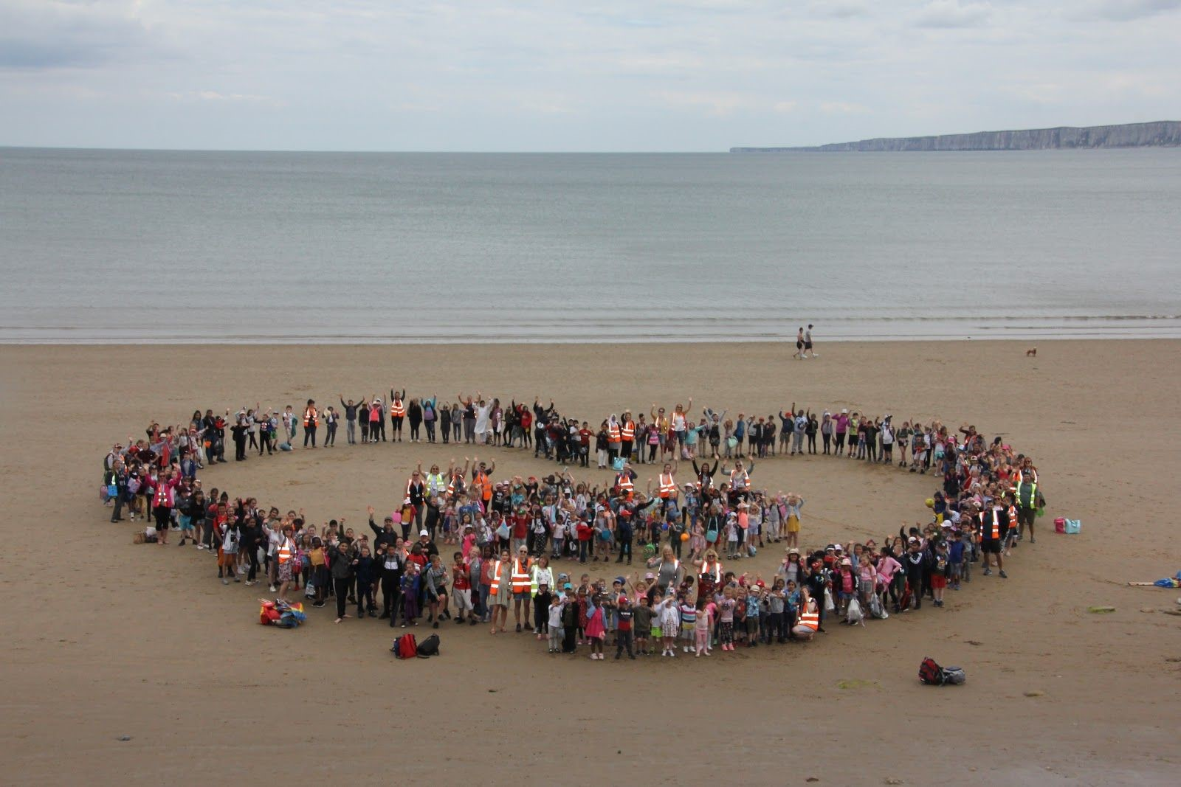
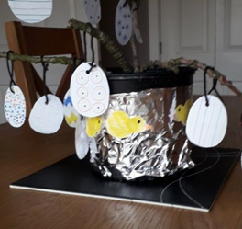

If you have anything you would like to add to this newsletter or have any suggestions, please contact Rebecca Oxley or Louise Allingham via their emails.
We will get through this - one day, one step at a time. Keep smiling.

