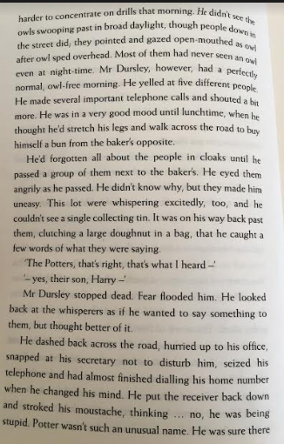
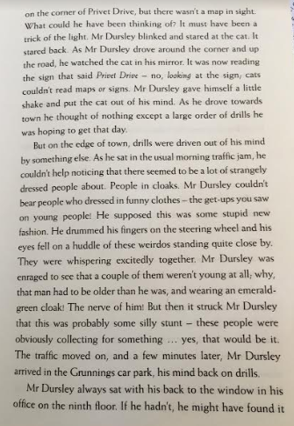
WCR Wednesday

Read pages 3-4
- T/F All Mr Dursley could think of as he was driving was what he was having for tea when he got home.
- What was the old man who was laughing at Mr Dursley wearing?
- Why did Mr Dursley go for walk at lunchtime?
- What did the people say as Mr Dursley walked past them with a large bag of donuts?
Challenge
- Order these events correctly:
He dashed back across the road
1

seized his telephone

hurried up to his office

changed his mind

snapped at his secretary not to disturb him

