WCR Tuesday
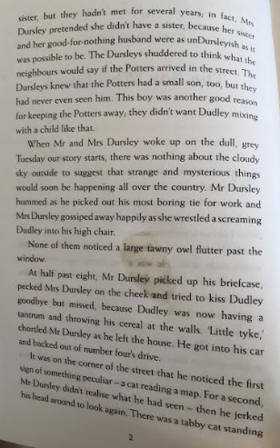
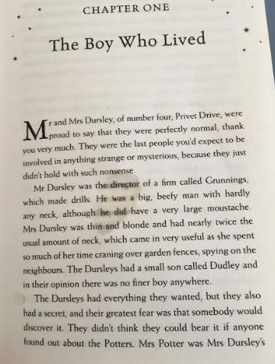
Read pages 1 -2

- Why were they the last people you would expect to be involved in anything strange or mysterious?
- How does the author describe Mrs Dursley?
- What was The Dursley secret?
- What type of owl fluttered past the window?
- What did Mr Dursley see at the corner of the street?
Challenge - explain what we can infer about their personalities from the physical descriptions.

