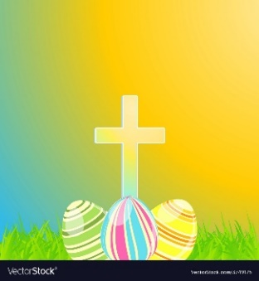
Year 5 Easter
Homework Menu

Choose at least 6 of the activities below to complete over the Easter holidays.
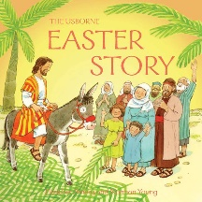  Retell the Easter Story | Art/DT  Draw/paint/make something that will put a smile on someone’s face during this tough time | Make an Easter Bonnet  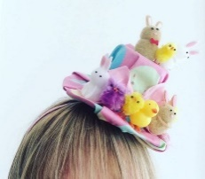 | Write a book review  It could be one we are reading together or one of your own!
Bake Easter Nest Buns  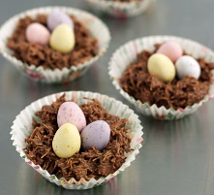 | Create an Easter Prayer  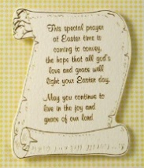 | Complete your own fun Science experiment! | Go on TT Rockstars, try beating your high score and changing your rock status!
Create your own PE game that you can teach to the Sports Leaders and Mr O’Brien  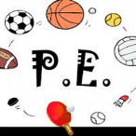 | Dens and Shelters  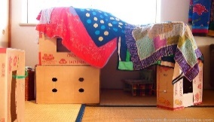  Can you use objects in your house to create a den/shelter to keep you dry from the Spring showers? It can be indoors or outdoors! | Toilet Roll ‘Keepy Uppy’ Challenge  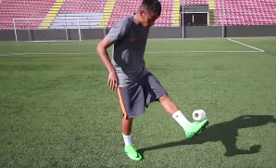  (Hopefully you will have toilet roll) Try to keep it off the floor with your feet for as long as you can. | Make a weather report.  Keep track of what the Spring weather is like. You could draw a picture or record a video.
Make your own Viking longboat  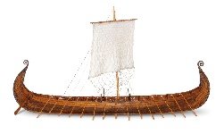 | Find out about some Viking legends/sagas!  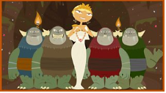 | Make your own Viking word search  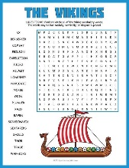 | Make Viking flatbreads!  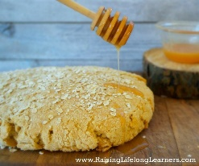

Useful websites:
Easter Nests - https://www.bbcgoodfood.com/recipes/shredded-wheat-nests
Science Experiments - https://www.businessinsider.com/8-awesomely-simple-science-experiments-you-can-do-at-home-2016-7?r=US&IR=T
Viking Sagas - https://www.bbc.co.uk/programmes/articles/20stJyBvh9mv7kpSVgDfKPw/viking-sagas-age-7-11
The Easter Story - https://www.topmarks.co.uk/easter/easterstory.aspx
Viking Soup - https://www.fotevikensmuseum.se/d/vikingar/hur/mat/recept/brod

