English Week 6
Day 5 Friday
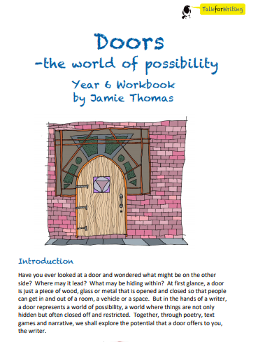
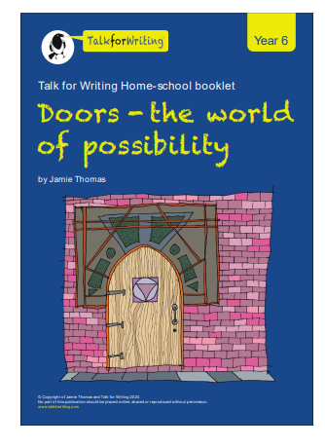

You may like to watch these videos to help with today’s work. Remember to stay safe whilst working online.
