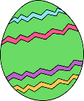  Egg starts with the letter ‘e’ - What else starts with the letter ‘e’? Write a list of things that start with the letter ‘e’. How many things can you think of? | 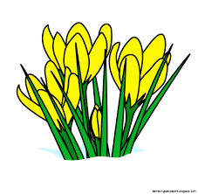  At Easter time lots of plants and flowers start to grow. Go for a walk around the park or your garden and see what flowers and plants you can see growing. | 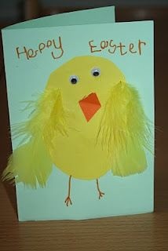  Can you create an Easter card for someone in your family?
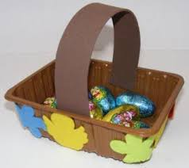  Try to make an Easter basket. You could use a cardboard box and decorate it with paints or colourful easter pictures. | 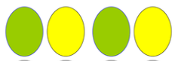  Can you make a repeated pattern of eggs using 2 colours? | 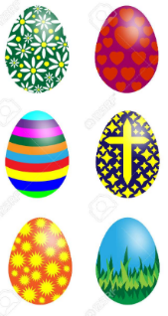  Draw and  carefully colour  a beautifully  patterned egg.
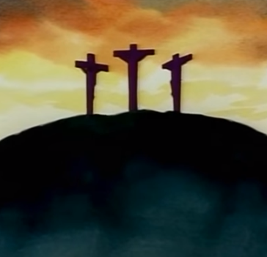  Watch the Easter story.  https://www.youtube.com/watch?v=0PSgoPdKQFQ | Draw a picture of a garden. Add the Easter bunny and some eggs.  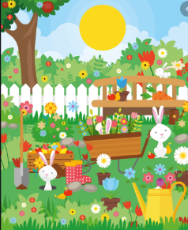 | Make salt dough Easter eggs. Roll out dough, cut into shapes, dry for a few days and decorate.  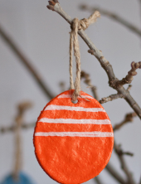  Salt dough  Cup of flour  ½ cup salt  ½ cup water
Make chocolate nests and add smarties or mini eggs.  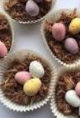 | List poem  Go outside with a grown up and list what you can  - See  - Hear  - Smell  - Touch  - How you feel | It is a tradition to decorate a hat at Easter. Decorate a real one or draw one instead.  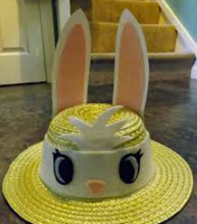
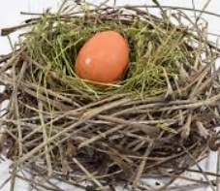  Make a nest .Put an egg in. | Learn a song and a dance.  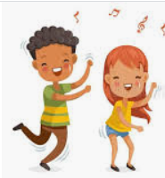 | Play a board game.  