Science – Week 4 – Floating/ sinking
Watch the following clip
https://www.youtube.com/watch?v=eQuW8G2QV_Q
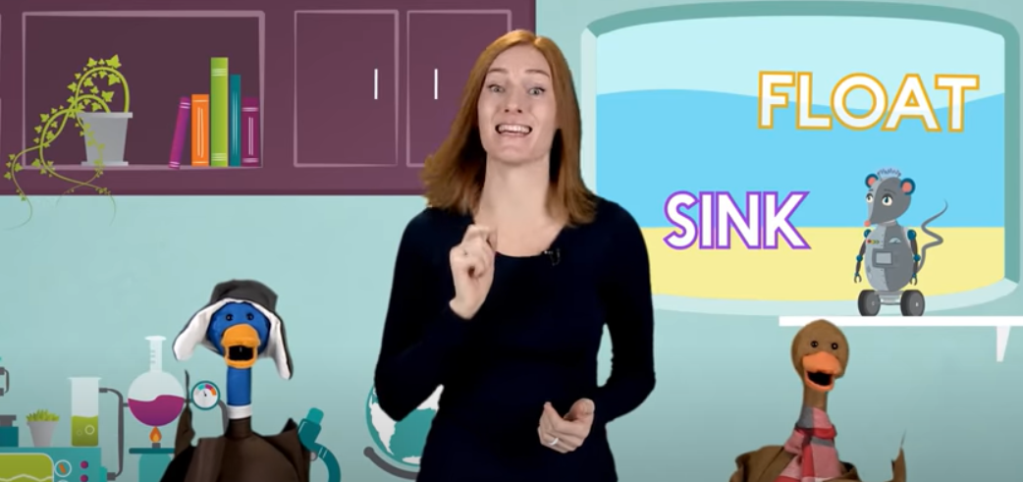
Does an egg sink or float? Does it depend of the liquid it is in?
Investigate if an egg will float or sink in different solutions. Mix the different materials in water.
Remember to make the test fair by keeping the volume of each solution the same and using the same amount of each material.

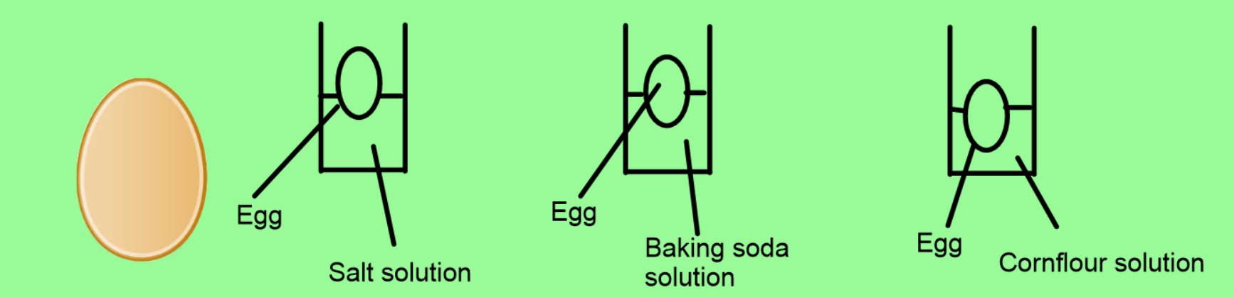

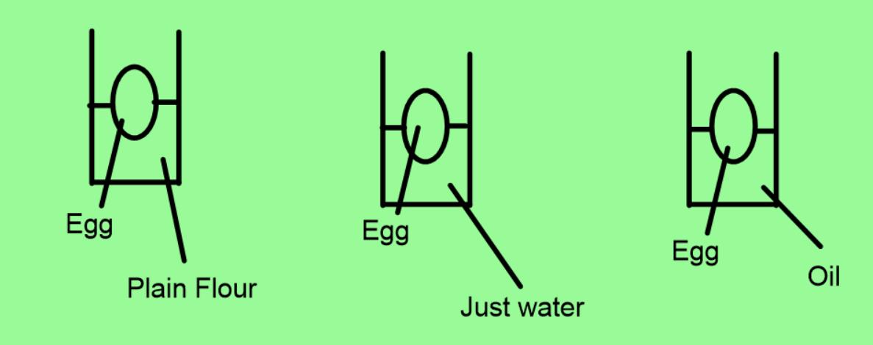

Take photos of your investigation and upload them to dojo or classroom.
What did you find out?
Does an egg always float or always sink?
What effect did each solution have on the egg?

