Thursday 14.5.2020
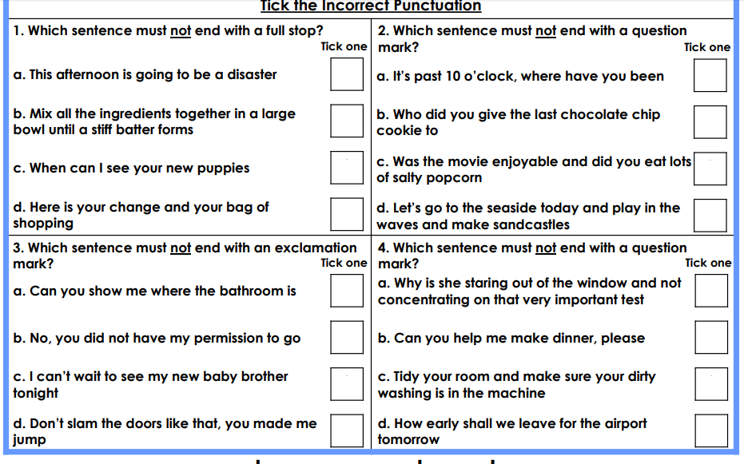
I.E

Miss Petty’s magical kenning poem:
Student-informer
Book-reader
Wish-enchanter
Knowledge-holder
Cloak-wearer
Wand-user
Spell-giver
What am I?
What magical object or person has Miss Petty described?!
Your turn! There is a word mat to support your ideas, but can you create your own word bank of magical items?!
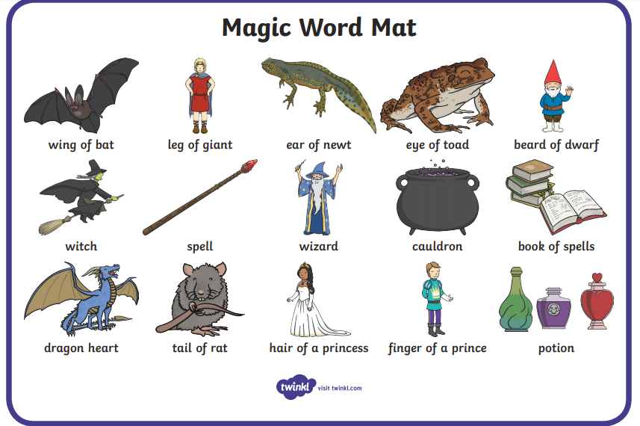
Step 1: Choose your own object, person, item which you are going to describe.
Step 2: Create your own word bank. One for nouns. One for verbs. (Miss Petty has done one below to show)
Step 3: Have fun and make sure your kenning makes sense.
Noun | Verb
Student book  wish knowledge  cloak wand spell | Informer reader enchanter holder wearer user giver

