Immediate engagement:

Can you create your own sentences (commands, statements, questions and exclamations!) and not include the punctuation so your friends have to add the correct punctuation marks?!
Eg

What am I supposed to do
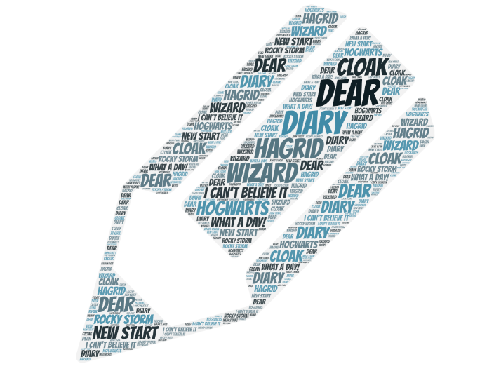
Get me a cup of tea




