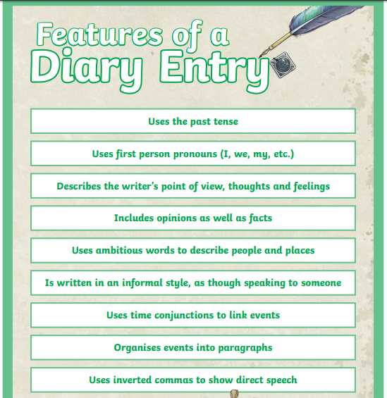
English 19.5.2020
Following the above features poster, can you please create your own diary entry based on your day? This needs to be informative and explain what you have done during the day, (it could also be something that you look at when you’re older).
You will then compare your first diary entry to your final diary entry which will be written by the end of the week.
Please remember each activity is a different a paragraph, add detail to how you were feeling!

