Annex 1

COVID-19 school closure arrangements for
Safeguarding and Child Protection at Academy St James Primary School

Date: March 2020
Date revised: May 2020
Date shared with staff:
Your school logo

1. Context

From 20th March 2020 parents were asked to keep their children at home, wherever
possible, and for schools to remain open only for those children of workers critical to
the COVID-19 response - who absolutely need to attend.

Schools and all childcare providers were asked to provide care for a limited number
of children - children who are vulnerable, and children whose parents are critical to
the COVID-19 response and cannot be safely cared for at home.

As we prepare for the wider opening of schools in accordance with the DfE guidance
https://www.gov.uk/government/publications/coronavirus-covid-19-guidance-on-vulnerable-children-and-young-people/coronavirus-covid-19-guidance-on-vulnerable-children-and-young-people , many of the actions put in place in March 2020 remain in force since a large number of children will remain at home.

This addendum of the Academy at St James Safeguarding and Child Protection policy
contains details of our individual safeguarding arrangements in the following areas:

1. Context
2. Vulnerable children and maintain contact
3. Attendance monitoring
4. Designated Safeguarding Lead
5. Reporting a concern
6. Safeguarding Training and induction
7. Safer recruitment/volunteers and movement of staff
8. Online safety in schools and colleges
9. Children and online safety away from school and college
10. Supporting children not in school
11. Supporting children in school
12. Peer on Peer Abuse

Key contacts

Role | Name | Contact Number | Email
Designated Safeguarding | Becky Albentosa | 01274 777095 | becky.albentosa@academystjames.com
Deputy Designated Safeguarding Lead | Chris Tolson | 07927 550611 | chris.tolson@academystjames.com
Deputy Designated Safeguarding Lead | Ruthi Thompson | 01274 777095 | ruth.thompson@academystjames.com
Deputy Designated Safeguarding Lead | Andy Smart | 01274 777095 | andrew.smart@academystjames.com
Safeguarding Governor | John Watts | 01274 777095 | john.watts@academystjames.com
Chair of Governors | Steven Emsley | 01274 777095 | stephen.emsley@bdat-academies.org

2. Vulnerable children

Vulnerable children include those who have a social worker and those children and
young people up to the age of 25 with education, health and care (EHC) plans.

Those who have a social worker include children who have a Child Protection Plan
and those who are looked after by the Local Authority. A child may also be deemed
to be vulnerable if they have been assessed as being in need or otherwise meet the
definition in section 17 of the Children Act 1989.

Those with an EHC plan will be risk-assessed in consultation with the Local Authority
and parents, to decide whether they need to continue to be offered a school or
college place in order to meet their needs, or whether they can safely have their
needs met at home. This could include, if necessary, carers, therapists or clinicians
visiting the home to provide any essential services. Many children and young people
with EHC plans can safely remain at home.

Eligibility for free school meals in and of itself should not be the determining factor
in assessing vulnerability.

Senior leaders, especially the Designated Safeguarding Lead (and deputy) know who
our most vulnerable children are. They have the flexibility to offer a place to those
on the edge of receiving children’s social care support.

ASJ will continue to work with and support children’s social workers to help
protect vulnerable children. This includes working with and supporting children’s
social workers and the local authority virtual school head (VSH) for looked-after and
previously looked-after children. The lead person for this will be: Becky Albentosa.

There is an expectation that vulnerable children who have a social worker will attend
an education setting, unless in consultation with the child’s social worker and family it is agreed this is not in the best interests of the child.

Where parents are concerned about the risk of the child contracting COVID19,
ASJ or the social worker will talk through these anxieties with the
parent/carer following the advice set out by Public Health England.

ASJ will encourage our vulnerable children and young people to attend a
school, including remotely if needed.

The ASJ is following government COVID-19 guidance on vulnerable children and young people, which is frequently updated. This can be viewed using the following link, https://www.gov.uk/government/publications/coronavirus-covid-19-guidance-on-vulnerable-children-and-young-people/coronavirus-covid-19-guidance-on-vulnerable-children-and-young-people

Maintaining contact with vulnerable families:
All vulnerable families are aware that they can contact the DSL on duty if they urgently need support.

School have created a RAG rated list of pupils that we will continue to contact regularly – some by phone and some through a visual check. The RAG is defined in the following way:

 | Most risk of harm  Possible neglect  All children with CP/CIN plan | Contact to be made twice a week – one must be doorstep if concerns arise during phone call. Parents can also message the teacher or a DSL through CPOMS if needed.  Visits from SW & other professionals requested if needed and meetings to go ahead for this group of pupils.  WHEN USING PHONE TO CONTACT, NEVER GIVE OUT YOUR PERSONAL PHONE NUMBER.
 | Moderate risk of harm but with some protective factors.  May have poverty problems which bring family into greater risk of not coping.  Those with an allocated Hub worker, or LAC/previous LAC/special guardianship.  Children with an EHC, children with significant needs who have an MSP. | Contact twice a week by phone. Parents can also message the teacher or a DSL through CPOMS if needed.  Where any concerns arise, doorstep contact for second contact.  Where there are concerns of abuse or neglect, make visible contact.
 | Some concerns escalating, some unmet need.  Previous SW involvement, or CAF. | Contact by nominated person once a week. Could be phonecall, or message on CPOMS/by phone from class teacher.

When visiting homes:
In cases of self-isolation, DSLs should take precautions to stand the required distance back from the child in order to see them.
DSLs should continue to ensure that they visit a home in pairs, to ensure their safety and to maintain school protocols.

3. Attendance monitoring

Local authorities and education settings do not need to complete their usual day-today
attendance processes to follow up on non-attendance.

However, ASJ will resume taking their attendance register from 1 June, although, parents and carers will not be penalised if their child does not attend school.

ASJ and social workers will agree with parents/carers whether children in
need should be attending school – ASJ will then follow up on any pupil that
they were expecting to attend, who does not. ASJ will also follow up with
any parent or carer who has arranged care for their child(ren) and the child(ren)
subsequently do not attend.

To support the above, ASJ will, when communicating with parents/carers
and carers, confirm emergency contact numbers are correct and ask for any
additional emergency contact numbers where they are available.
In all circumstances where a vulnerable child does not take up their place at school,
or discontinues, ASJ will notify their social worker.

Vulnerable children – regardless of year group – that have not been attending in the recent period are now expected to return to school where this would now be appropriate for them to do so.

4. Designated Safeguarding Lead

Academy at St James Primary school has a Designated Safeguarding Lead (DSL) and 3 Deputy DSL’s.

The Designated Safeguarding Lead is: Becky Albentosa
The Deputy Designated Safeguarding Lead is: Chris Tolson
The Deputy Designated Safeguarding Lead is: Ruth Thompson
The Deputy Designated Safeguarding Lead is: Andy Smart

The optimal scenario is to have a trained DSL (or deputy) available on site. Where
this is not the case a trained DSL (or deputy) will be available to be contacted via
phone or online video - for example when working from home.

Where a trained DSL (or deputy) is not on site, in addition to the above, a senior
leader will assume responsibility for co-ordinating safeguarding on site.

This might include updating and managing access to child protection online
management system, CPOMS and liaising with the offsite DSL (or deputy) and as
required liaising with children’s social workers where they require access to children
in need and/or to carry out statutory assessments at the school or college.

Whatever the scenario, we will ensure that all ASJ staff and volunteers have access to a trainedDSL (or deputy). On each day staff on site will be made aware of that person is and
how to speak to them.

The DSL will continue to engage with social workers, and attend all multi-agency
meetings, which can be done remotely.

5. Reporting a concern

Where staff have a concern about a child, they should continue to follow the process
outlined in the school Safeguarding Policy, this includes making a report via CPOMS,
which can be done remotely.

In the unlikely event that a member of staff cannot access their CPOMS from home,
they should email the Designated Safeguarding Lead and Deputy DSL. This will ensure that the concern is received.

Staff are reminded of the need to report any concern immediately and without
delay.

Where staff are concerned about an adult working with children in the school, they
should report the concern to the headteacher immediately. If there is a
requirement to make a notification to the headteacher whilst away from school, this
should be done verbally and followed up with an email to the headteacher.
Concerns around the Headteacher should be directed to the Chair of Governors.

6. Safeguarding Training and induction

DSL training is very unlikely to take place whilst there remains a threat of the COVID
19 virus.

For the period COVID-19 measures are in place, a DSL (or deputy) who has been
trained will continue to be classed as a trained DSL (or deputy) even if they miss
their refresher training.

All existing school staff have had safeguarding training and have read part 1 of
Keeping Children Safe in Education (2019). The DSL should communicate with staff
any new local arrangements, so they know what to do if they are worried about a
child.

Where new staff are recruited, or new volunteers enter ASJ, they will
continue to be provided with a safeguarding induction.

If staff are deployed from another education or children’s workforce setting to our
school, we will take into account the DfE supplementary guidance on safeguarding
children during the COVID-19 pandemic and will accept portability as long as the
current employer confirms in writing that:-

• the individual has been subject to an enhanced DBS and children’s barred list
Check

• there are no known concerns about the individual’s suitability to work with
Children

• there is no ongoing disciplinary investigation relating to that individual
Upon arrival, they will be given a copy of the receiving setting’s child protection
policy, confirmation of local processes and confirmation of DSL arrangements.

7. Safer recruitment/volunteers and movement of staff

It remains essential that people who are unsuitable are not allowed to enter the
children’s workforce or gain access to children. When recruiting new staff, ASJ will continue to follow the relevant safer recruitment processes for their setting, including, as appropriate, relevant sections in part 3 of Keeping Children Safe in Education (2019) (KCSIE).

In response to COVID-19, the Disclosure and Barring Service (DBS) has made
changes to its guidance on standard and enhanced DBS ID checking to minimise the
need for face-to-face contact.

Where ASJ are utilising volunteers, we will continue to follow the checking
and risk assessment process as set out in paragraphs 167 to 172 of KCSIE. Under no
circumstances will a volunteer who has not been checked be left unsupervised or
allowed to work in regulated activity.

ASJ will continue to follow the legal duty to refer to the DBS anyone who
has harmed or poses a risk of harm to a child or vulnerable adult. Full details can be
found at paragraph 163 of KCSIE.

CVPS will continue to consider and make referrals to the Teaching Regulation
Agency (TRA) as per paragraph 166 of KCSIE and the TRA’s ‘Teacher misconduct
advice for making a referral.

During the COVID-19 period all referrals should be made by emailing
Misconduct.Teacher@education.gov.uk

Whilst acknowledging the challenge of the current National emergency, it is essential
from a safeguarding perspective that any school is aware, on any given day, which
staff/volunteers will be in the school or college, and that appropriate checks have
been carried out, especially for anyone engaging in regulated activity. As such,
ASJ will continue to keep the single central record (SCR) up to date as
outlined in paragraphs 148 to 156 in KCSIE.

8. Online safety in schools and colleges

ASJ will continue to provide a safe environment, including online. This
includes the use of an online filtering system.

Where students are using computers in school, appropriate supervision will be in
place.

Any identified children that have been chosen to have online access at home using a school device will be subject to the AUP and this will be monitored accordingly using school’s online filtering system.

9. Children and online safety away from school and college

It is important that all staff who interact with children, including online, continue to
look out for signs a child may be at risk. Any such concerns should be dealt with as
per the Child Protection Policy and where appropriate referrals should still be made
to children’s social care and as required, the police.

Online teaching should follow the same principles as set out in the school code of
conduct.

ASJ will ensure any use of online learning tools and systems is in line with
privacy and data protection/GDPR requirements.

Below are some things to consider when delivering virtual lessons, especially where
webcams are involved:

• No 1:1s, groups only
• Staff and children must wear suitable clothing, as should anyone else in the
household.
• Any computers used should be in appropriate areas, for example, not in
bedrooms; and the background should be blurred.
• The live class should be recorded so that if any issues were to arise, the video
can be reviewed.
• Live classes should be kept to a reasonable length of time, or the streaming
may prevent the family ‘getting on’ with their day.
• Language must be professional and appropriate, including any family
members in the background.
• Staff must only use platforms provided by ASJ to communicate
with pupils
• Staff should record, the length, time, date and attendance of any sessions held.

10. Supporting children not in school

ASJ is committed to ensuring the safety and wellbeing of all its Children and
Young people.

Where the DSL has identified a child to be on the edge of social care support, or
who would normally receive pastoral-type support in school, they should ensure that
a robust communication plan is in place for that child or young person.

Details of this plan must be recorded on CPOMS, as should a record of contact have
made.

The communication plans can include; remote contact, phone contact, door-step
visits. Other individualised contact methods should be considered and recorded.

ASJ and its DSL will work closely with all stakeholders to maximise the
effectiveness of any communication plan.

This plan must be reviewed regularly (at least once a fortnight) and where concerns
arise, the DSL will consider any referrals as appropriate.

The school will share safeguarding messages on its website and social media pages.

ASJ recognises that school is a protective factor for children and young
people, and the current circumstances, can affect the mental health of pupils and
their parents/carers. Teachers at ASJ need to be aware of this in setting
expectations of pupils’ work where they are at home.

ASJ will ensure that where we care for children of critical workers and
vulnerable children on site, we ensure appropriate support is in place for them. This
will be bespoke to each child and recorded on CPOMS.

ASJ will use the DfE guidance on mental health and behaviour in schools to help identify
children who might need additional support, and to put this support in place. This guidance can be viewed using the following link , https://www.gov.uk/government/publications/mental-health-and-behaviour-in-schools--2

11. Supporting children in school including social distancing

ASJ is committed to ensuring the safety and wellbeing of all its students.

ASJ will continue to be a safe space for all children to attend and flourish.

The Headteacher will ensure that appropriate staff are on site and staff to pupil ratio
numbers are appropriate, to maximise safety.

ASJ will refer to the Government guidance for education and childcare
settings on how to implement social distancing and continue to follow the advice
from Public Health England on handwashing and other measures to limit the risk of
spread of COVID19.

ASJ will ensure that where we care for children of critical workers and vulnerable children on site, we ensure appropriate support is in place for them. This will be bespoke to each child and recorded on CPOMS.

Where ASJ has concerns about the impact of staff absence – such as our
Designated Safeguarding Lead or first aiders – will discuss them immediately with
the LA.

How to maintain social distancing within the school setting

We have been guided to make the following decisions:

- Between every ‘lesson’ the students will wash their hands.

- Classroom use will be prioritised by size. Students can sit one to a desk; social distancing without feeling isolated.

- Wipe down technology after use, so that germs cannot be passed from one device to another

- PE. We will do sport each day. Guidelines issued by UK government press conference on Friday suggested the risk from sport is low providing the social aspect is minimised.

- Use “respect his/her personal space” So the supervisor can remind the students with that cue on the first instance and then follow with a more direct instruction if needed if needed at break time

Posters to support the procedures to be used at all times:

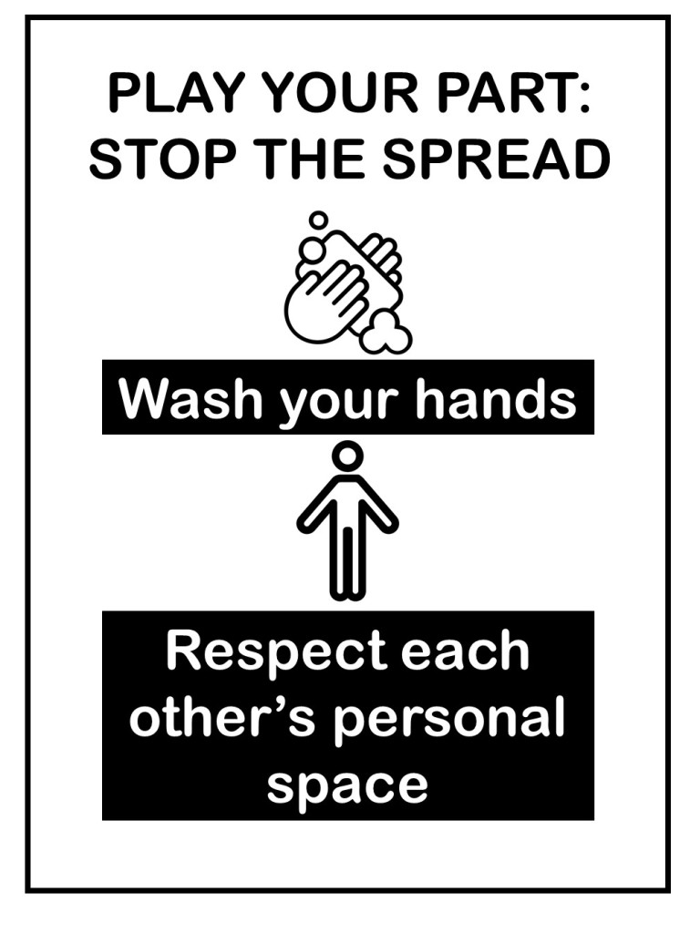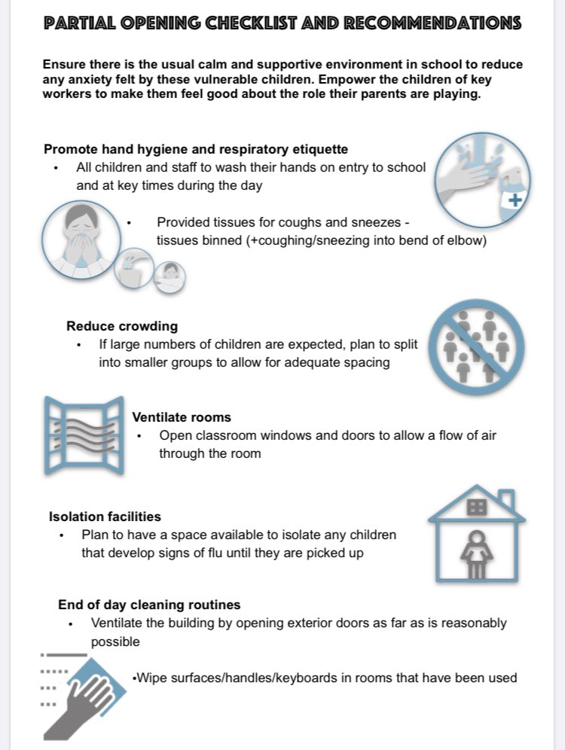
12. Peer on Peer Abuse

ASJ recognises that during the closure a revised process may be required
for managing any report of such abuse and supporting victims.

Where a school receives a report of peer on peer abuse, they will follow the
principles as set out in part 5 of KCSIE and of those outlined within of the Child
Protection Policy.

The school will listen, led by the Designated Safeguarding Lead ( or a Deputy ) and work with the young person, parents/carers and any multi-agency partner required to ensure the safety and security of that young person.

Concerns and actions must be recorded on CPOMS and appropriate referrals made.

