Computing
Scratch Lesson 2

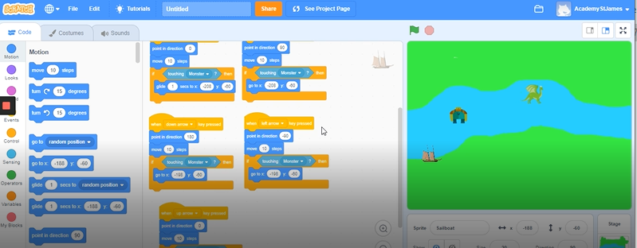

The next part of our Scratch project is to build in some variables. This means we select blocks that have an ‘input’ and an ‘output’.

‘If ……. then .....’

In real life terms an example could be:
‘If you are thirsty then get a drink.’

In our game, we are going to have the input of
‘If you touch the monster or dragon then go back to the beginning.’

Watch the following clip to see how I did it and then have a go yourselves.

https://www.loom.com/share/3e278ddee7e945f6b4f84f0f7c5c3842

