Wednesday - Creating a gruesome monster
Over the next few lessons we will be learning how to write a “defeating the monster” story.
Our WAGOLL (What A Good One Looks Like) is taken from the book – “Beowulf”.
Task 1
Read the first bit of the WAGOLL.
- What does the word weary mean?
- What does the word roam mean?
- What do you know about King Hrothgar already?

Today, we will be creating a gruesome monster description ready to use later on in our stories.
To create a monster you could:
- pick out some gruesome details using adjectives to describe the eyes, mouth, nose, ears, arms, legs, feet, toes, hair, body.
- Use the senses – touch/ feel, sight, smell, taste, hearing
- Use similes to compare something using “like” or “as” to something else that is nasty!
Task 2
Describe a gruesome monster – this could be one that you have completely made up or one from the pictures below. Use the word bank to help you. Remember to use a thesaurus to help you find the best adjectives that you can come up with.
e.g. AS the vulgar creature ascended from the depths of the polluted, carbon smelling swap, it’s evil, wide eyes cut through misty surroundings like a sharp bladed knife. It’s elongated, bony fingers were pointy like an eagle’s talons.
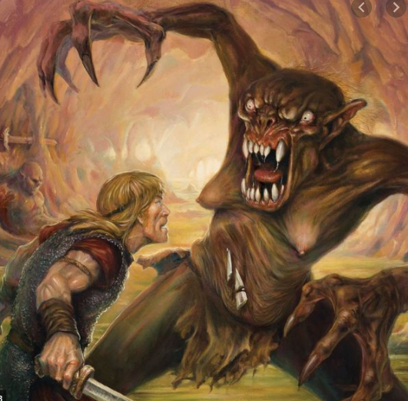
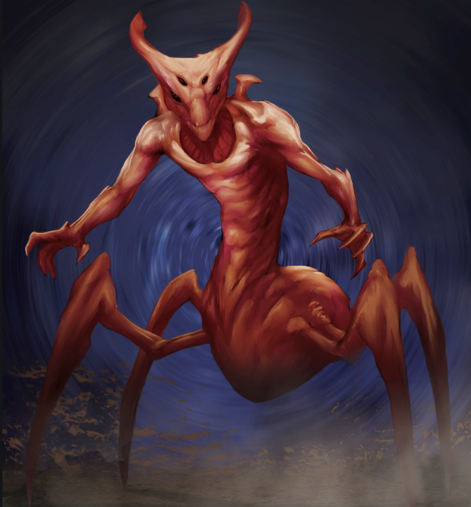
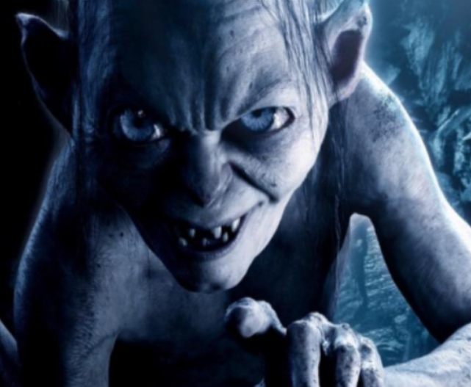
Gollum – Lord of the Rings

Word bank
Piercing broad vast vicious savage ruthless
Eerie sinister lengthy rugged jagged wicked disgusting
Elongated gnarled
Similes
as sharp as a dagger twisted like the branches of a tree as rough as the surface of sandpaper

