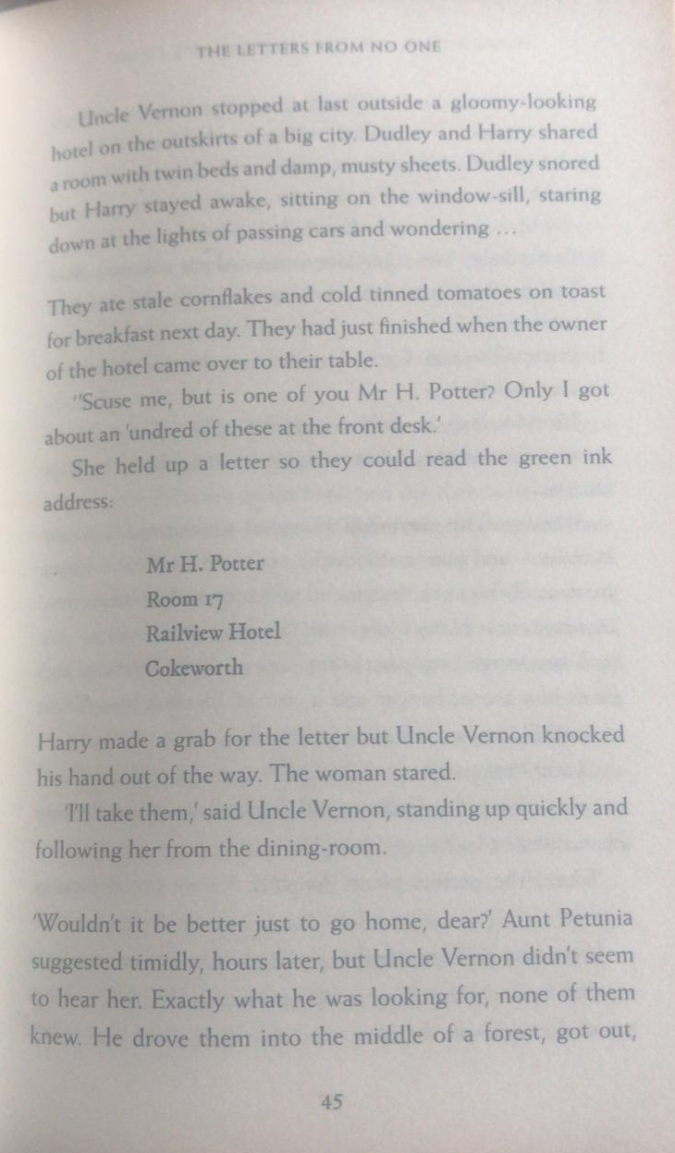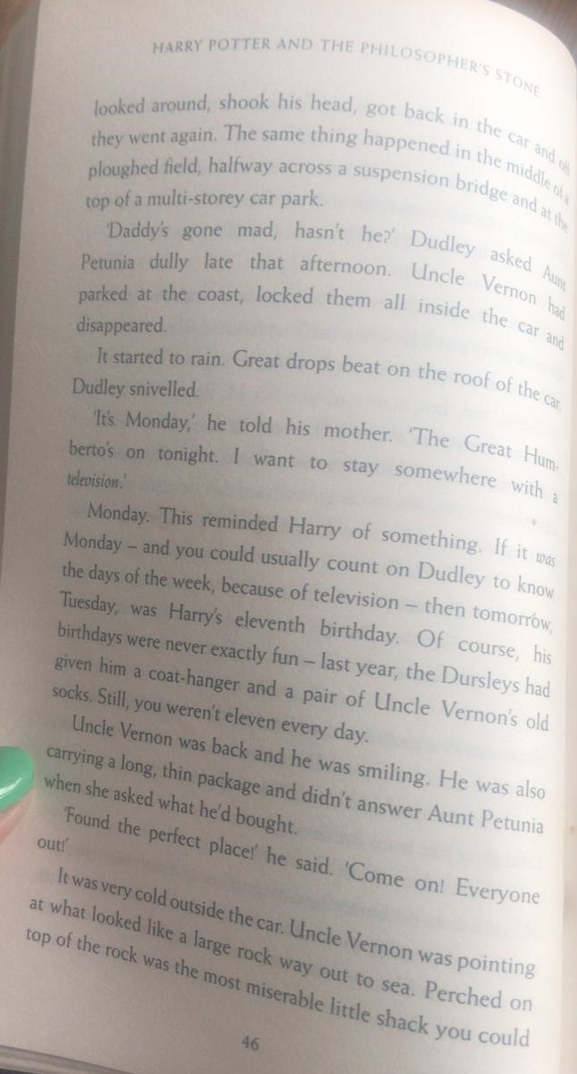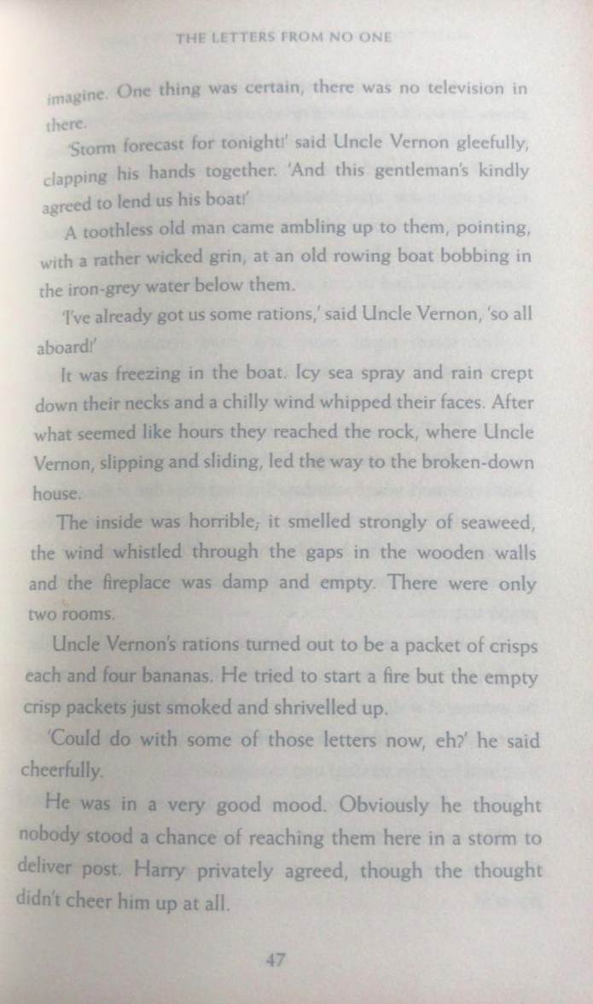

Questions for pages 45 - 47
- Write two things that they ate the next morning at the hotel.
- Why was that Monday an important day?
- Which phrase suggests the journey by boat felt long?
- Write two reasons why the house was an unpleasant place to stay.

Now, read up to the end of page 49 to finish The Letters from No One chapter and think about this statement.
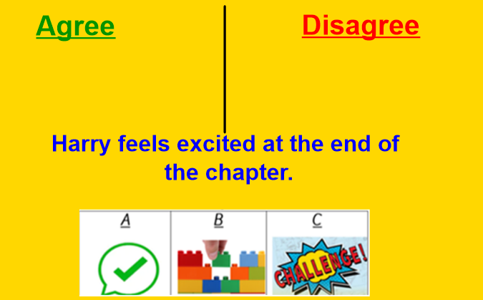
Consider reasons why you agree and disagree with statement. A debate will be started by the adults!
