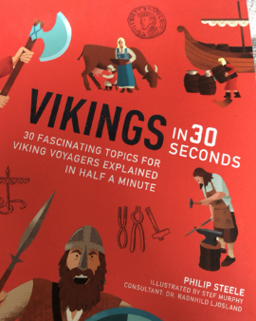
Reading
Friday 8th May 2020

Pages 18-19 Law and Order
Top 5
Fill in the boxes below stating what you think are the top 5 facts about Law and Order in the Viking era.

