Friday – week 8 –
https://www.bbc.co.uk/bitesize/articles/zkkm6v4
Use the website to help explain how to solve these questions.

Simplify fractions

How to simplify fractions
In this video from KS2 Maths a runner simplifies fractions to find out how close they are to the finish line.
You can simplify a fraction if the numerator (top number) and denominator (bottom number) can both be divided by the same number.
Six twelfths can be simplified to one half , or 1 over 2 because both numbers are divisible by 6 .
6 goes into 6 once and 6 goes into 12 twice.

A method for simplifying fractions
Watch this film to understand how a bar model can be used to simplify a fraction.

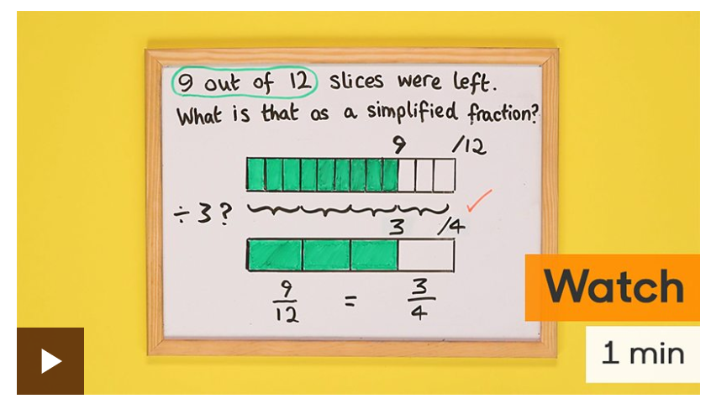
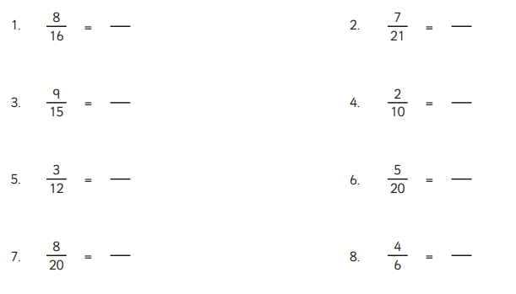

Now try these:-
