Gospel lesson 3.
REcap!

What does Gospel mean?
Can you remember what disciple means? Write a definition.

Who were the two disciples we learnt about last week?
What sacrifices did Jesus ask them to make?

Glossary - sacrifice (verb) - give up (something valued—possession, animal, time) for the sake of other considerations.
-----------------------------------------------------------------------------------------
Last week, we looked at when Jesus called his First Disciples (Matthew 4:18–19). We are going to continue to explore that this week.

Our Biblical text is –
Jesus Calls His First Disciples (Matthew 4:20–22)
20 At once they left their nets and followed him. 21 Going on from there, he saw two other brothers, James son of Zebedee and his brother John. They were in a boat with their father Zebedee, preparing their nets. Jesus called them, 22 and immediately they left the boat and their father and followed him.

Below are two videos showing this scene from the Bible:
https://request.org.uk/restart/2018/01/09/calling-of-the-disciples/
https://www.youtube.com/watch?v=tJGxaRFc-fA (fast forward to 1:00 into avoid a very squeaky song!)
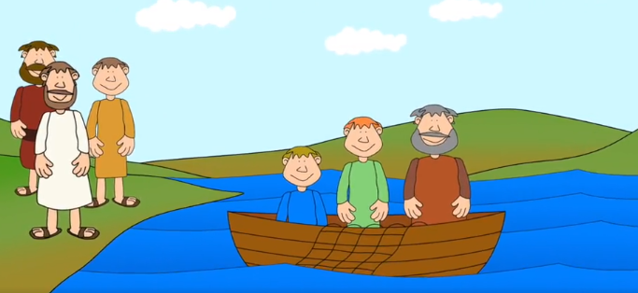
What did James and John leave behind?

What special new job have the disciples gained once they follow Jesus?

What Jesus might have meant by ‘fisher of people’?
Create images of what a ‘fisher of people’ might do.

