Gospel lesson 4.
REcap!

What does Gospel mean?
What did ‘fishers of people’ mean? Write a definition.

Write the name of Jesus’ first disciples?

Glossary - sacrifice (verb) - give up (something valued—possession, animal, time) for the sake of other considerations.
-----------------------------------------------------------------------------------------
Before we read a new Biblical text, take a look at the photos of the people below.
Which of them would you help if you saw they were in need?
Think about who you would help first, and write why that would be.

Our Biblical text is –
Jesus Heals a Man With Leprosy (Mark 1:40-44)
⁴⁰ A man with leprosy^{[a]} came to him and begged him on his knees, “If you are willing, you can make me clean.”
⁴¹ Jesus was indignant.^{[b]} He reached out his hand and touched the man. “I am willing,” he said. “Be clean!” ⁴² Immediately the leprosy left him and he was cleansed.
⁴³ Jesus sent him away at once with a strong warning: ⁴⁴ “See that you don’t tell this to anyone. But go, show yourself to the priest and offer the sacrifices that Moses commanded for your cleansing, as a testimony to them.”
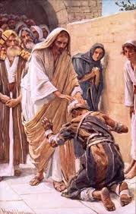
Below is a video showing this scene from the Bible:
https://www.youtube.com/watch?v=4KHGoXBjoOo

This story is important, because Jesus helped
someone who was unlikely to be helped by others.
At the moment, we are not in school or allowed to go near people because we don’t want the infection to spread. Leprosy is a very infectious disease, which damages skin and the nervous system.
https://www.leprosymission.org.uk/about/about-leprosy/

People with leprosy were treated very cruelly in Biblical times, maybe similar to people who have been in prison today.
However, would you blame people for not wanting to touch or be near the man with leprosy?
How does Jesus show love to all in this story? What did he do that was so special?

