Week 6 Tuesday
Reading
Read p. 24 and p.25 – Making Boats
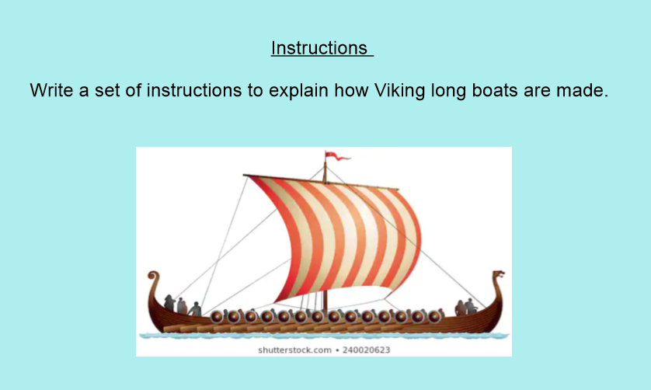

Remember to include the following:
Me
Introduction
What you will need
What to do
Warning or top tip
Time connectives
Imperative (bossy) verbs
Bullet points
Numbers

