RE – The 5 Pillars of Islam

Re-cap- Ramadan
- What do people do during Ramadan?
- eat all day
- nothing
- fast
- sleep all day
- How long is Ramadan?
- 1 week
- 15 days
- 60 days
- 30 days
- When is Eid?
- In the middle of Ramadan
- The 5th day of Ramadan
- At the start of Ramadan
- At the end of Ramadan

What are the 5 Pillars of Islam?
After finding out what the 5 pillars of Islam are, we are going to make a booklet to tell other people about them. There are instructions for how to make a booklet out of one sheet of paper. There are also video instructions. Your booklet will be to inform other children about the 5 pillars so make sure that you explain things as simply as you can.

What are the five Pillars of Islam?
These are five duties that every Muslim is obliged to perform. The five pillars of Islam help Muslims put their faith into action.
- Shahadah: declaration of faith
"I bear witness that there is no god, but God; I bear witness that Muhammad is the prophet of God." By reciting this, one enters Islamic faith.
- Salah: prayer
Muslims are required to pray five times a day, washing themselves before prayer and facing in the direction of Mecca while praying.
- Zakat: giving a fixed proportion to charity
Muslims are required to give away a percentage of their earnings to those less fortunate, regardless of their religion.
- Saum: fasting during the month of Ramadan
Muslims fast for one lunar month each year, a period called Ramadan. During this time, Muslims reflect on their behaviour and strive to purify their thoughts.
- Hajj: pilgrimage to Mecca
If it is financially possible, Muslims are required to travel to Mecca once in their lifetime.
Find out more by watching this clip.
https://www.bbc.co.uk/teach/class-clips-video/religious-education-ks2-my-life-my-religion-what-is-islam/zbmrwty

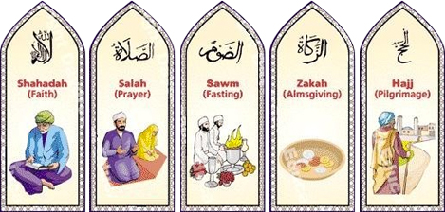

Instructions for the booklet

- Start with your piece of A4 paper landscape.
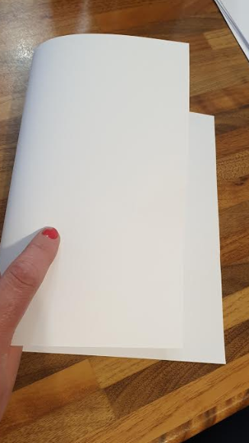
- Fold it in half (left to right)
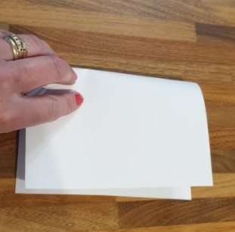
- Fold it in half again (top to bottom)
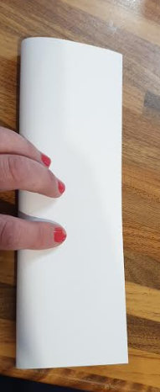
- open the last fold back up
- fold it in half again (left to right)
- open it all back up completely – have it landscape again
- fold it in half from top to bottom
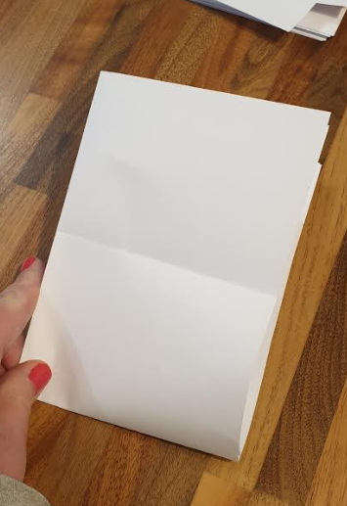
- fold it in half again (left to right)
- draw a line from the folded edge to the centre fold – about 1cm from the top
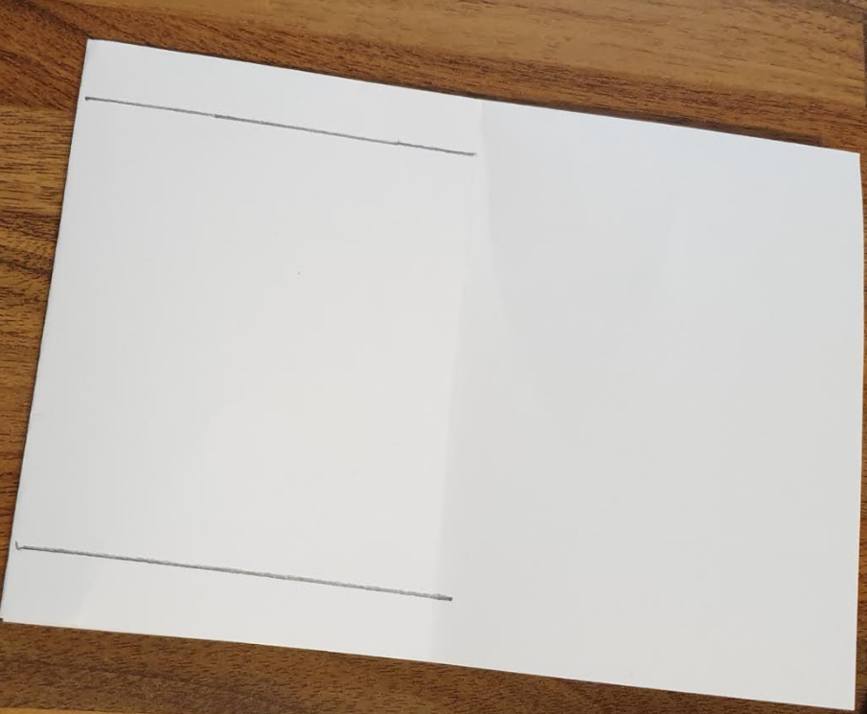
- repeat that but this time 1cm from the bottom
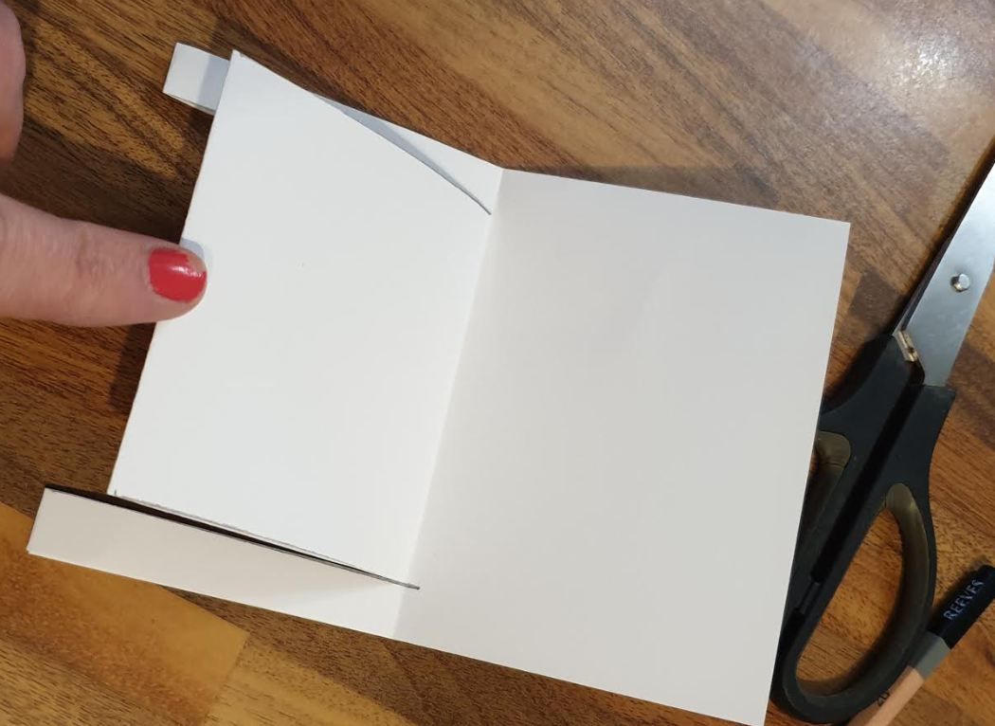
- cut along those lines
- unfold the last fold and then cut up the centre fold – Be careful not to cut the two 1cm bits that you left at the top and bottom.
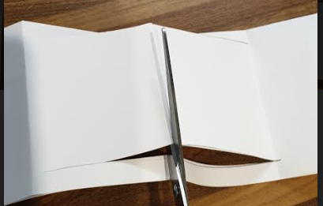
- fold back the flaps you have created slightly, so they stand up.
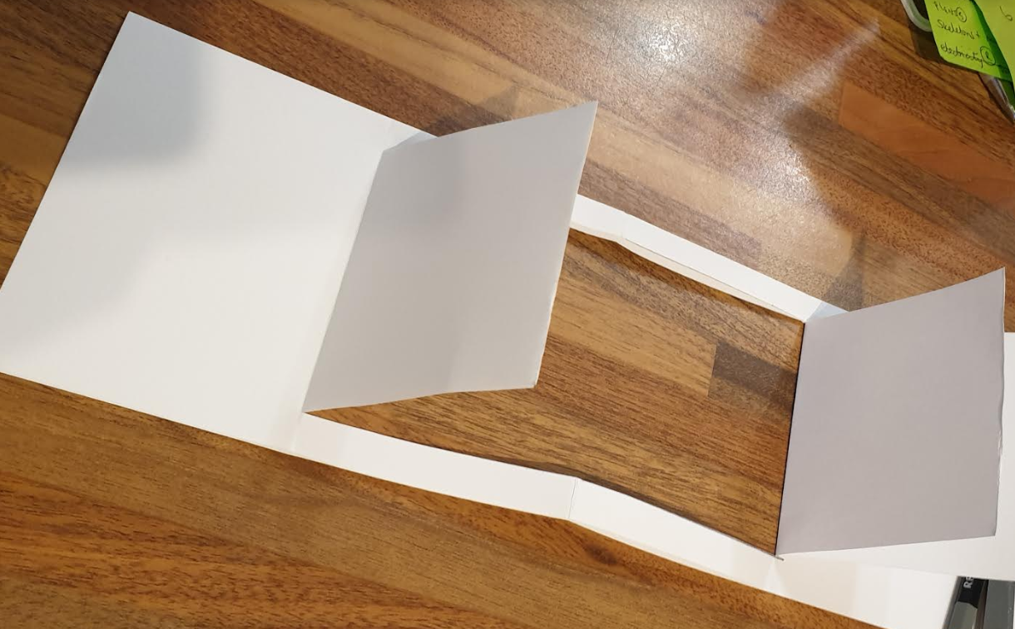
- bend the left and the right sections back and tuck the right one inside the left one so that the booklet stands up.
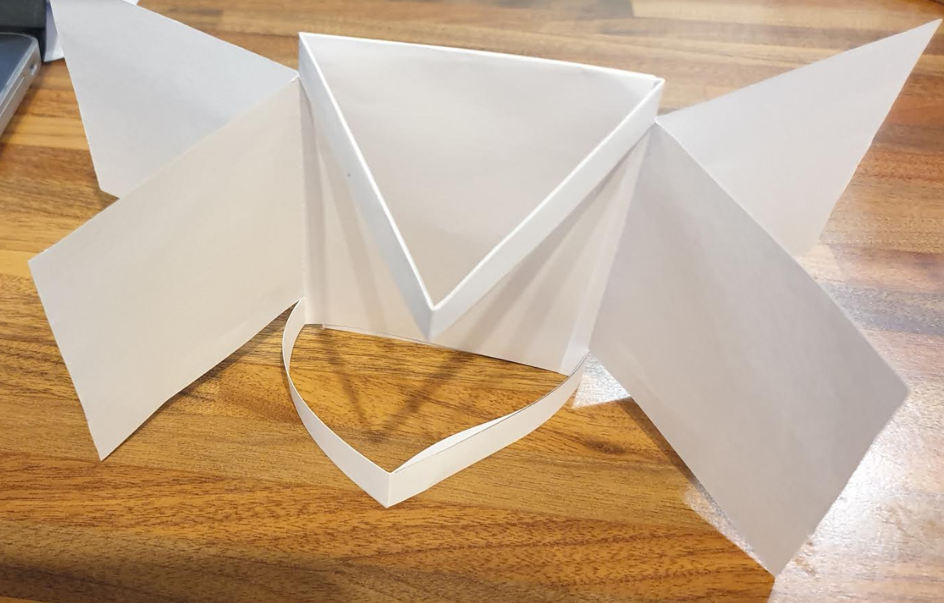

Once you have finished making the booklet, you can unfold it again and write on the pages. It’s up to you present the work in the booklet – make it as exciting and interesting as possible.
