Monday
Kennings
Kenning poems originated in Anglo-Saxon and Norse language. In a kenning, an object is described in a two word phrase which is linked with a hyphen e.g. bone-cruncher.
Kenning example – describing a Viking/ Norse man
Ship- decorator
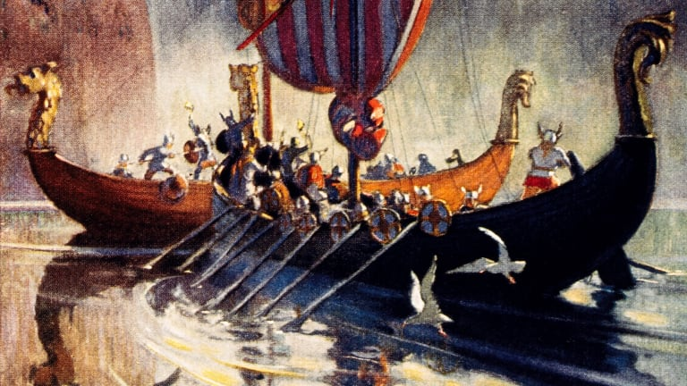
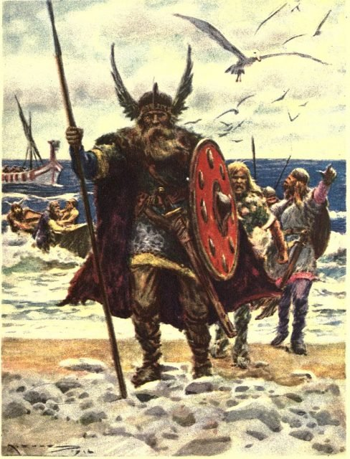
Round-facer
Damage-taker
Army-ambusher
Rival- ruiner
Opponent-crusher
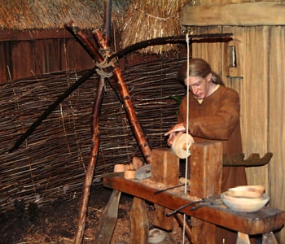
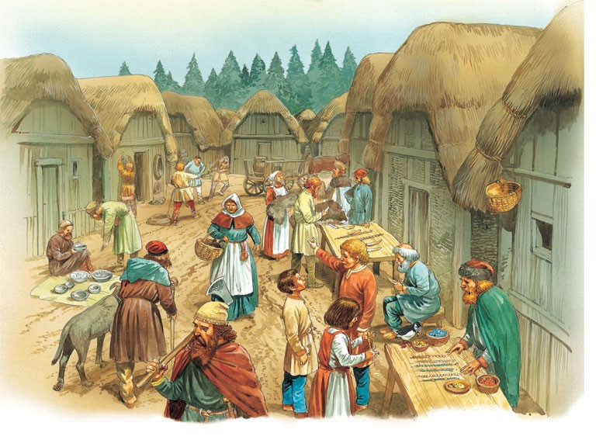
Body-obstructor
Arrow- interceptor
Sword-deflector

What were the Vikings like? What did they do? What did people think of them?
Have a go at writing your own kenning about a Viking from what you know already about Vikings.
Word bank for ideas

craftsmen traders warriors soldiers sailors farmers fighters

fierce noble gentle skilled brutal barbaric fearless

sword shield long boat Britain invader

