Is forgiveness better than punishment?

Why is it sometimes hard to forgive?

Do you think it is important to be able to forgive to get into the Kingdom of Heaven?

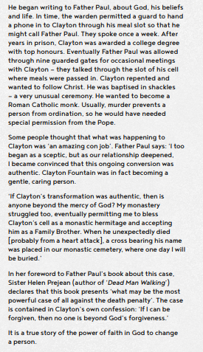

What questions come to mind as you read this article?
Should a murder be forgiven?

