Music
Lesson 1

How does music make you feel?
By changing elements of music, you can change the mood of a song.
Songs can make you feel different emotions. Some songs make you feel happy or excited, while others make you feel sad or scared.
These feelings come from how the song is composed, the instruments used and how performers play them.

Watch the following clip to understand more:

https://www.bbc.co.uk/bitesize/topics/zcbkcj6/articles/zc7m7p3

Activity 1
Listen to the song Dancing In The Street by Martha & The Vandellas.
Complete the questions below and add any other thoughts/feelings you may have.
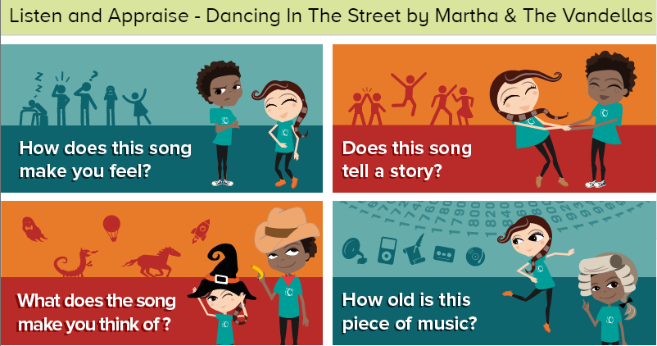

How does the song make you feel?

Does this song tell a story?

What does this song make you think of?

How old is this piece of music?

Continued on next page

Activity 2
Think about how your favourite songs make you feel. Listen again and see if you can spot what is causing those feelings.
Create a Diagram/photograph/video of yourself listening to either Dancing in the street or your favourite song and annotate with your feelings and why it makes you feel that way.

e.g.
Has an 80’s theme about it
Makes me feel happy
Upbeat feeling – fast tempo
I like the synthesiser in the bridge
Catchy lyrics and tune
Can create funny dances to it
Blinding Lights – The Weekend

