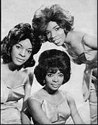
Music
Lesson 2

Listen to Martha and The Vandellas again from the last lesson to refresh your memory.
Then, listen to The Four Tops – I Can’t Help Myself.
These are both Motown songs. Motown originated in the USA and popularised soul music.

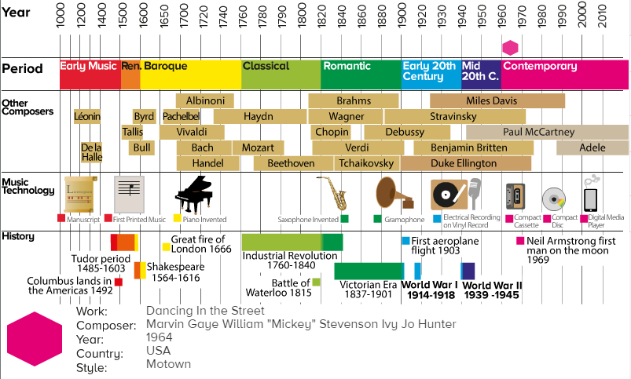

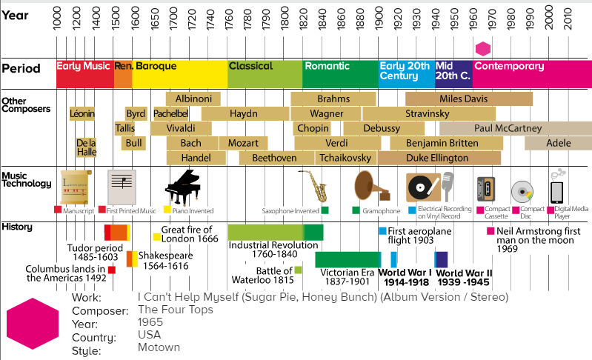

Complete the table below to show what similarities and differences they have.
How are the songs different, how are they similar? Have a look at the time period of Motown, what can you tell me?

Martha and The Vandellas – Dancing in the Street/ The Four Tops – I Can’t Help Myself
Similarities | Differences

