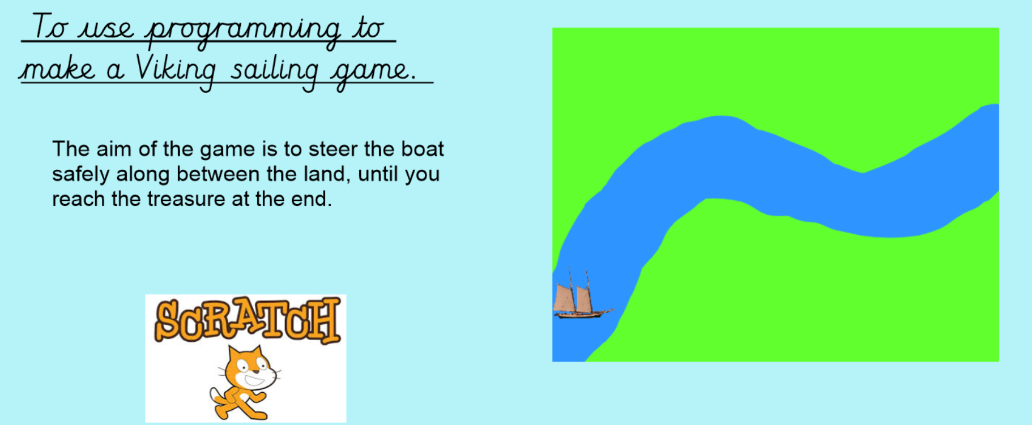
Lesson 1 – introduction
We are going to make a game using Scratch.
We will write a program so that we can make a boat move along the sea, in between the land. The boat will be controlled by the keys on a computer keyboard.
Along the way, we will have to write the algorithms to make everything work and if something goes wrong, we will have to de-bug the algorithm and make changes to it – trial and improvement!
If you are using Scratch on a computer, open it up and click “Create” to start a new project.
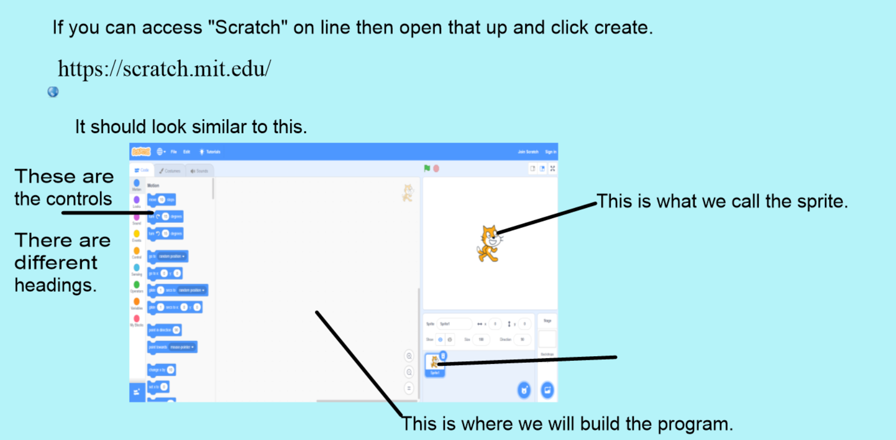

- we need to change the sprite. We don’t want a cat – we need a boat.
Click the bottom right hand side button with the cat head+ on it.
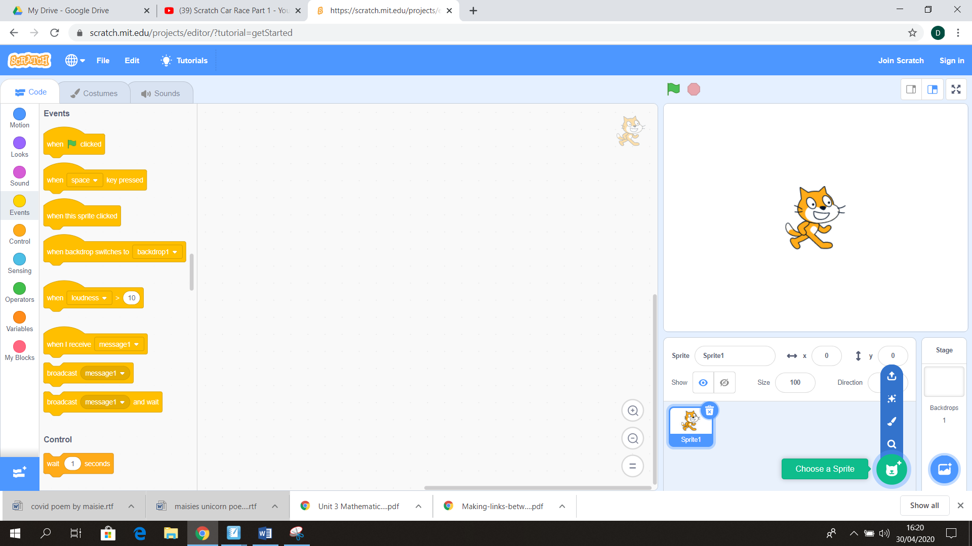
Click here

Change the cat to a boat.

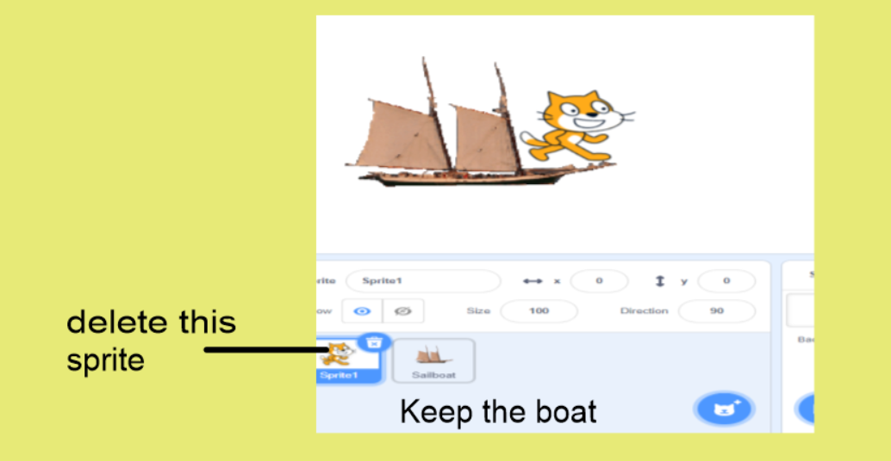
- Next, we need to paint the background
You have been working on the sprite so far, so before you can make the background, you need to change to working on the “stage”.
You do this by clicking on the “Stage” button on the right hand side
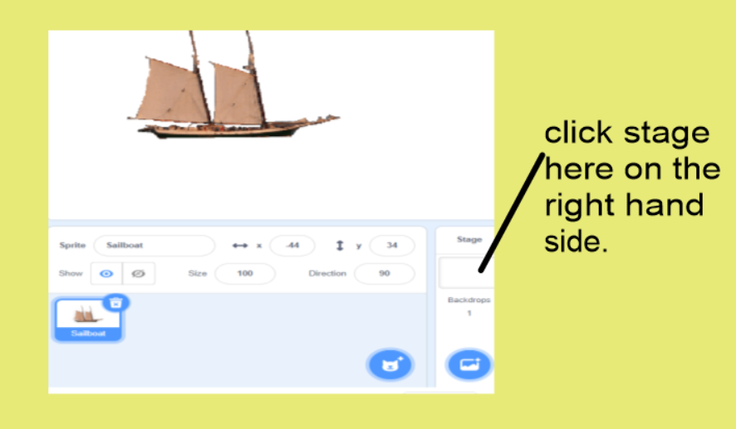

We need to paint the backdrop so now you have the backdrop tab on the top left hand side.
click on that.
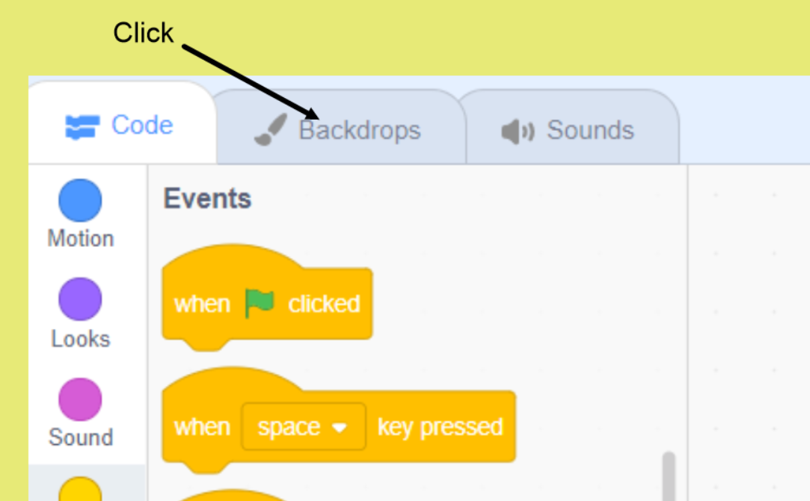
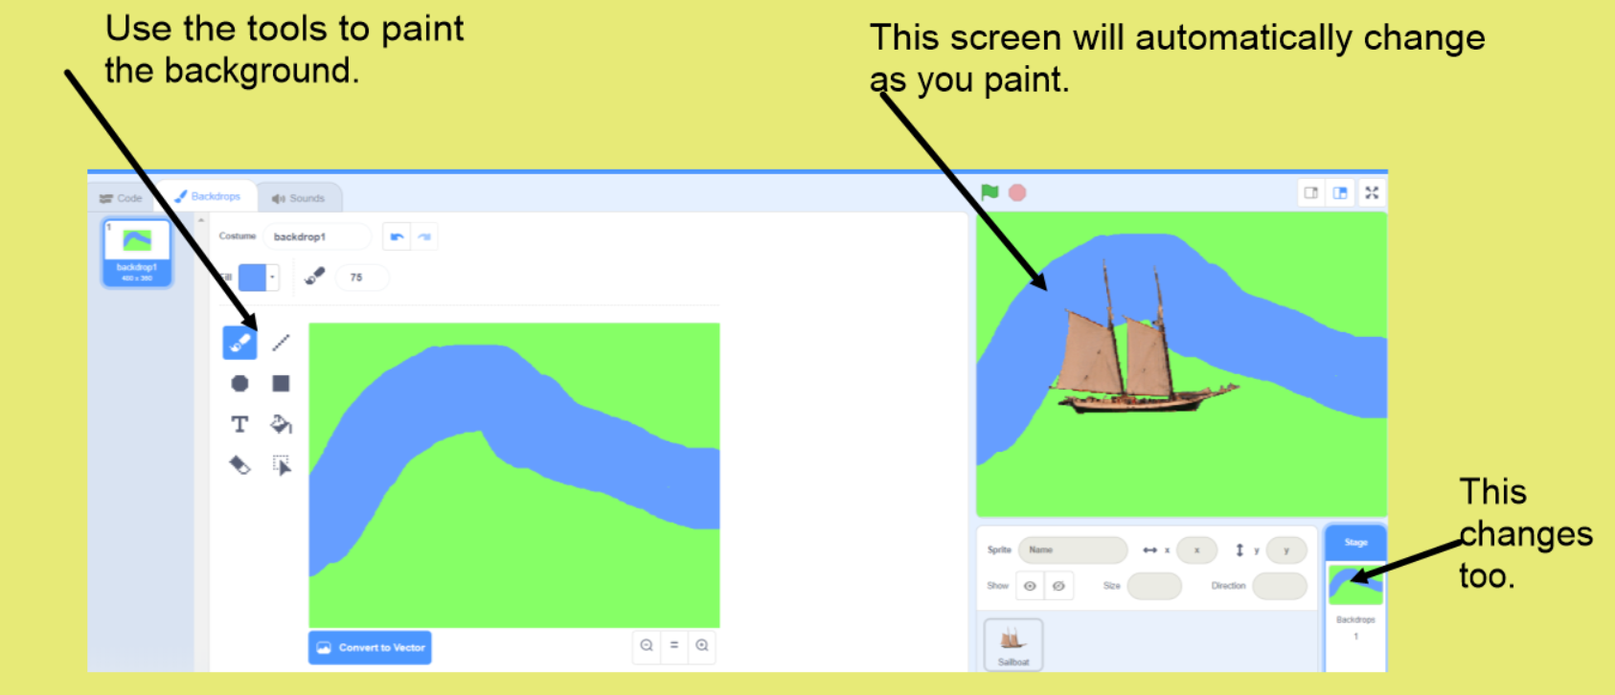
- We need to change the size of the boat now as it’s too big.
Click back on the sprite picture at the bottom, then use the size button to make it smaller.
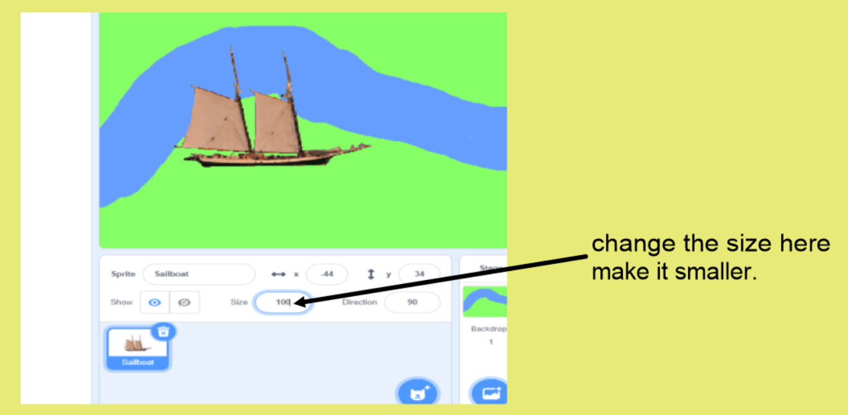

Next, drag the boat to the left hand side of the blue sea, ready to start programming!

- Clide code at the top left hand side
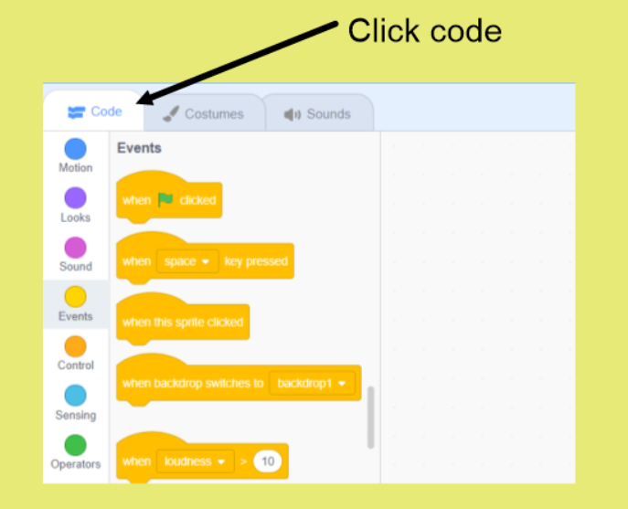

Now we are ready to add the controls and variables.

We want the boat to move to the right when we press one of the keys on the keyboard, so we need to write a code for that to happen.
We need an event – “when ---pressed”. So using the event codes, drag the one that says “when space pressed” to the middle of the screen.

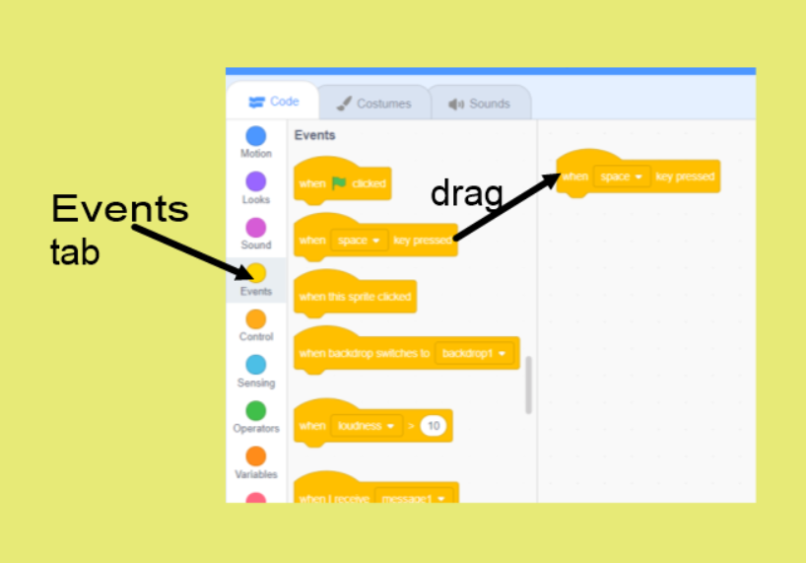

You can then change “space” to whichever key you want to use to move the boat right. An arrow key would work well.

The instruction now says that when a key is pressed something is going to happen, but we need to tell it what will happen. We need a motion. We need the sprite to move.

Using the motion tab, drag “move 10 steps” across to link with the event.
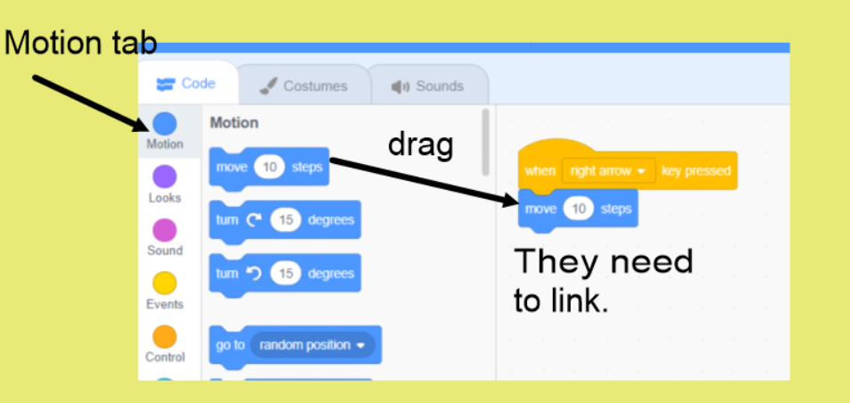

Time to test it!
If you have done this correctly, when you click on the boat sprite again (bottom right of the screen) then you press the arrow key, the boat in the sea should move!
If not, you need to de-bug your algorithm and try again to improve it.

- If that was successful, we need to do a similar process and give it a command so that the boat will move backwards when another key is pressed.
Create the same algorithm again, but this time change “move 10 steps” to “move -10 steps”. Because it has the minus sign, the boat should move back the other way!
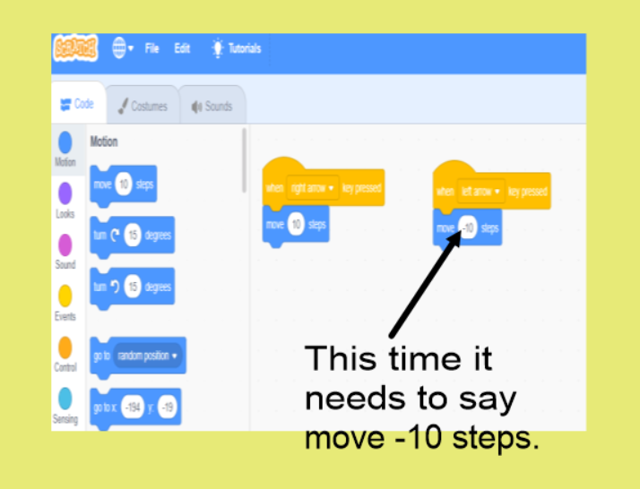

Try it!
Click on the sprite and see if your keys make it move.

Next lesson, we will make it turn left/ right!

