RE – Islam lesson 3
The second of the 5 Pillars of Islam is Salat / Salah
What is Salat/ Salah?
Watch the video and read the text to learn more about it.
https://www.bbc.co.uk/teach/class-clips-video/religious-education-ks2-my-life-my-religion-prayer-in-islam/zjndxyc
https://www.bbc.co.uk/religion/religions/islam/practices/salat.shtml
Task
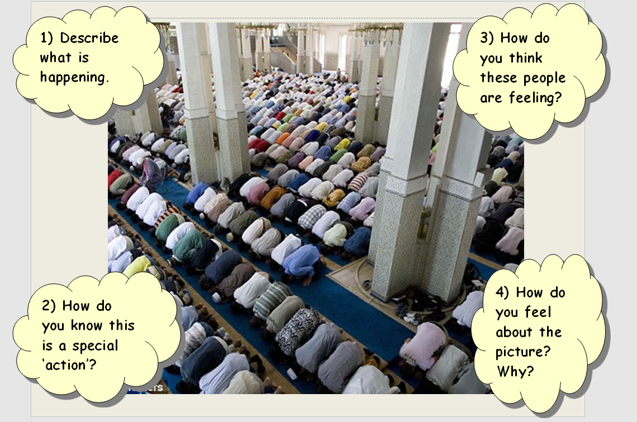
Then:
