Maths – Week 9 – Day 4 Two pages today!
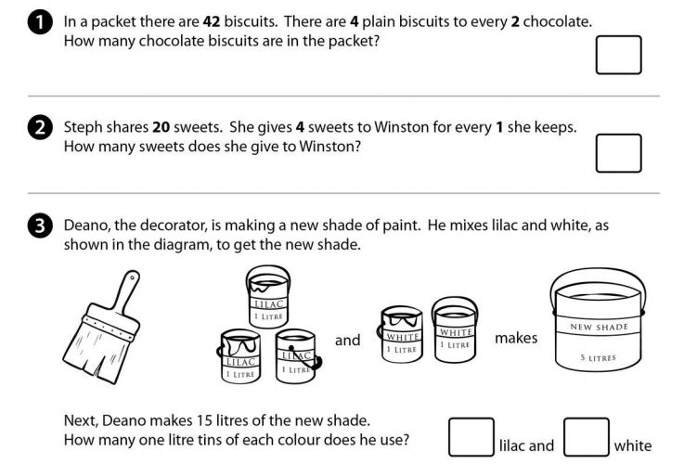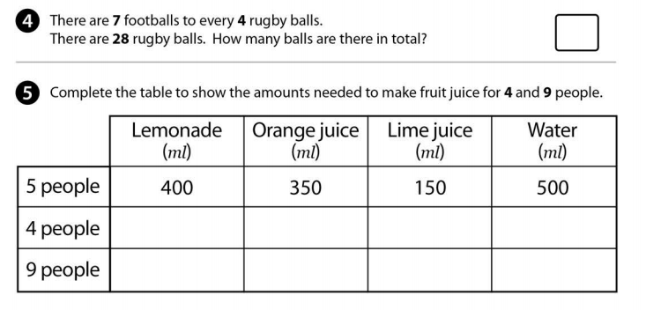

Use the link from bbc bitesize if you need a recap about algebra. Remember you can also message one of the year 6 team if you need help.
https://www.bbc.co.uk/bitesize/topics/zghp34j
