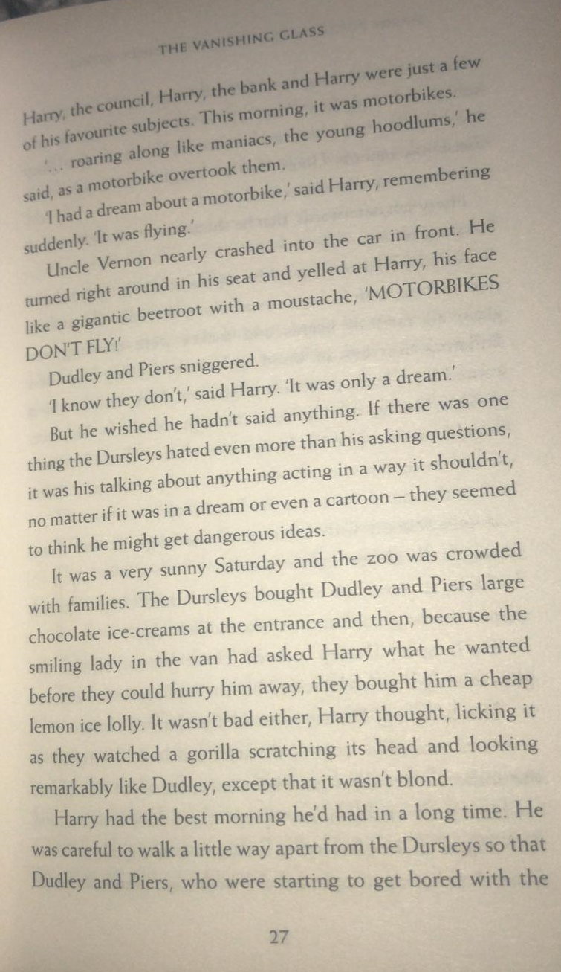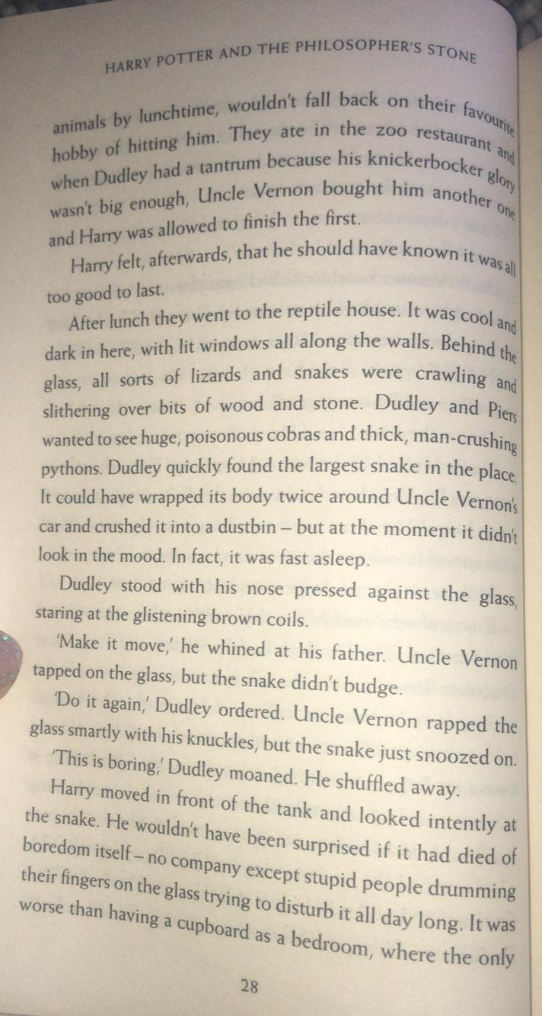
Questions
- Find and copy the simile page 27 used to describe Uncle Vernon?
(Remember – a simile compares two nouns, using like… or as…as…, e.g. The giraffe was towering like a skyscraper; The flowers were as vibrant as a rainbow.)
- Read the paragraph beginning, ‘But he wished he hadn’t…’ on page 27.
Why didn’t the Dursleys like Harry asking questions or talking about unusual things?
- Which two verbs on page 28 suggest that the snakes and lizards were moving?
- What would the largest snake in the reptile house be capable of doing, according to page 28?

Use the information on pages 27 and 28 to complete the thought bubbles for Dudley and the snake.

