Monday:
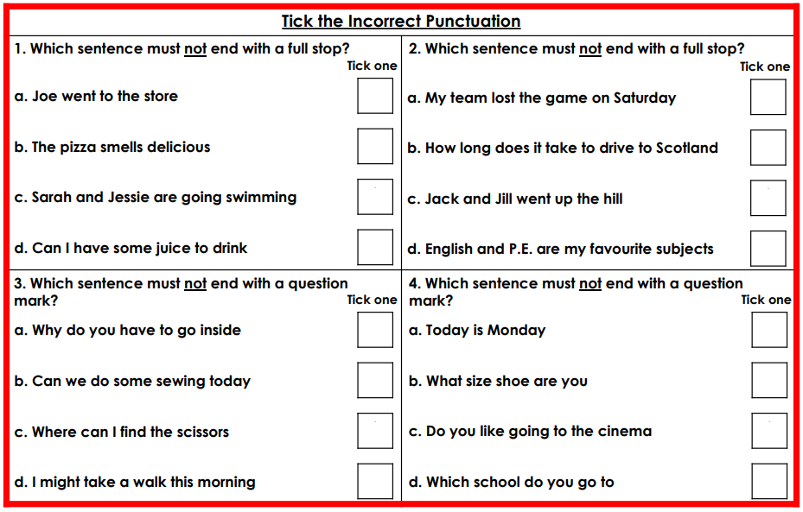
Immediate Engagement:

Prediction. Can you please predict what our next unit of English will be about? What do you think we will be practising to write?
(HINT: There’s a huge clue in the word cloud!)
Use the word cloud to make your predictions.
You are free to write down your predictions on paper and send the picture back to your teacher edit on this document and send back or film yourself making your prediction and send it to your teacher.

I predict that…
Based on the words provided…
After seeing the word,……, I believe that….
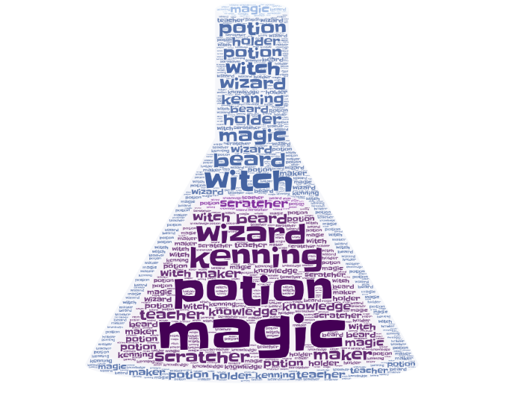
After having a discussion with my family, I now believe that….

