Monday 18th May 2020
Maths
Decimal and Fraction Equivalents
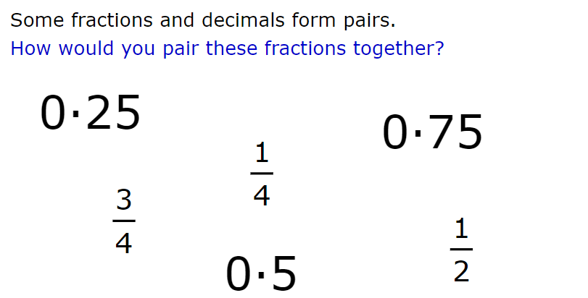

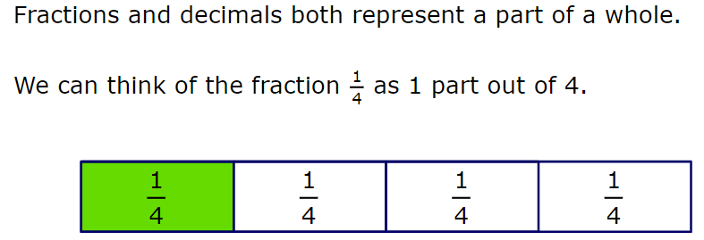

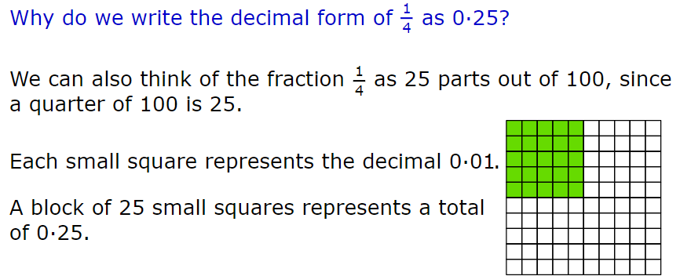

25 out of the 100 squares are shaded therefore written as a fraction is 25/100.
If we use a place value grid, we would write 25/100 as:
25/100 = 0.25
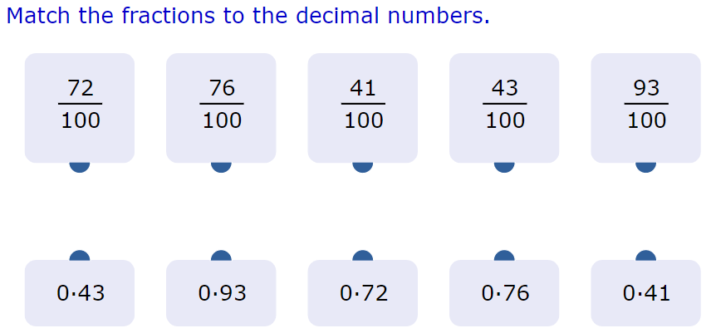

Have a go at changing these fractions to decimals. Use a place value grid to help you.

Fraction | Decimal
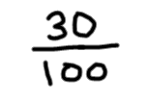
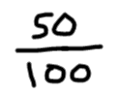
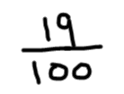
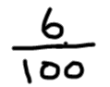

Now go the opposite way from a decimal to fraction. Check the fraction at the end to see if you can simplify it further.
Decimal | Fraction | Fraction in simplest form
0.56
0.24
0.82
0.03

Challenge
