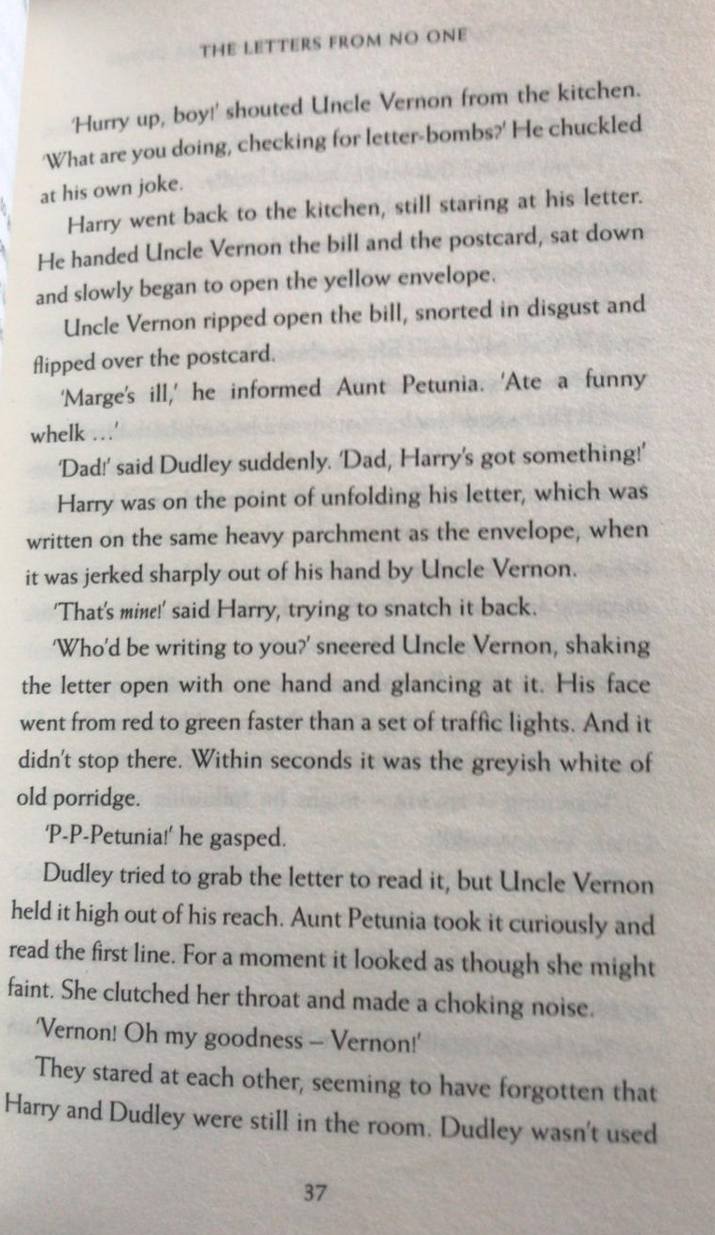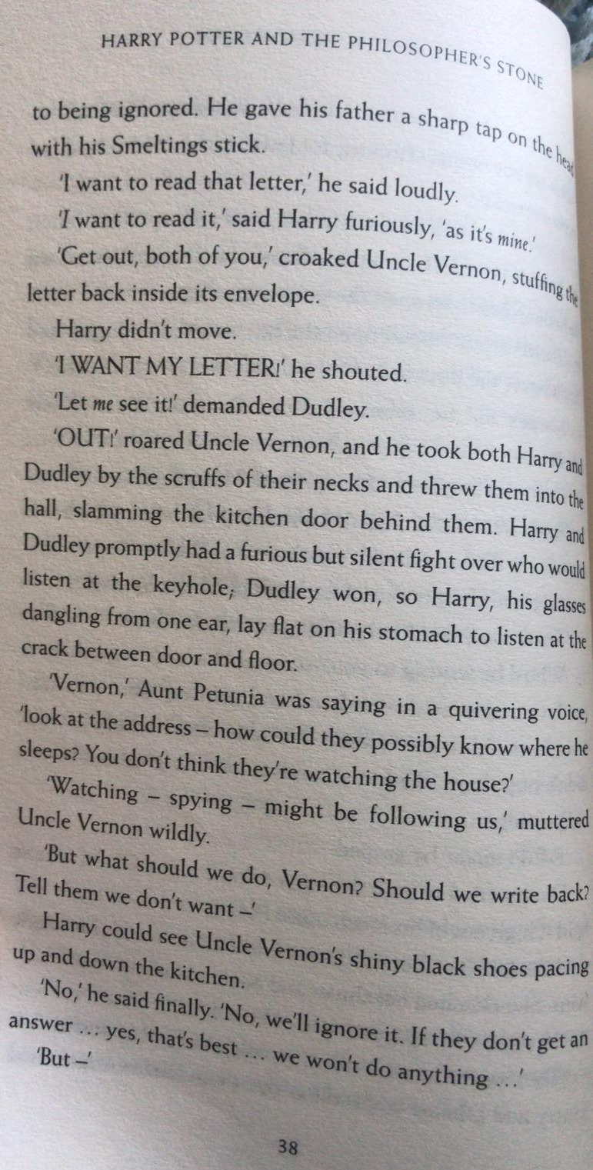
Questions
- How did Uncle Vernon feel about the bill he received? Explain your answer, with reference to the text.
- Find and copy the phrase, which tells us Uncle Vernon took the letter aggressively?
- Find and copy the phrase which tells us Aunt Petunia was scared, when she spoke?
- Why did Aunt Petunia think the senders of the letter might be watching the house?

Decision Wheel
On the next page are four different options for the Uncle Vernon and Aunt Petunia – add good (+) and bad (-) reasons for each one. Then, use these reasons to explain which is the best option for them to choose.
Are there any other options they could consider?

Remember, reasons could be better for them, Dudley, Harry or all of them.

