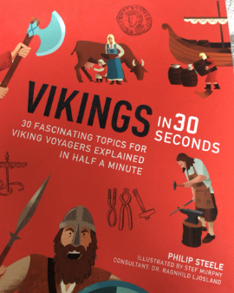
Reading
Monday 4th May 2020

- Find and copy the phrase that tells you rumours spread very quickly.

- What did the armed raiders on the ships do when they got to towns/villages?
State two different things.

- What countries did the Vikings come from?

- What were Vikings good at other than being fierce warriors? List them all.

- Why are the things archaeologists found important to us?

