Date:_____________________________________________________________-
LI: to be able to predict and make inferences using clues
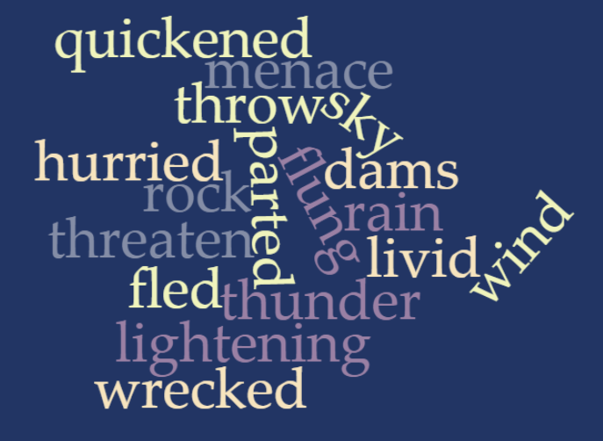
Word | What it tells use about our next text

