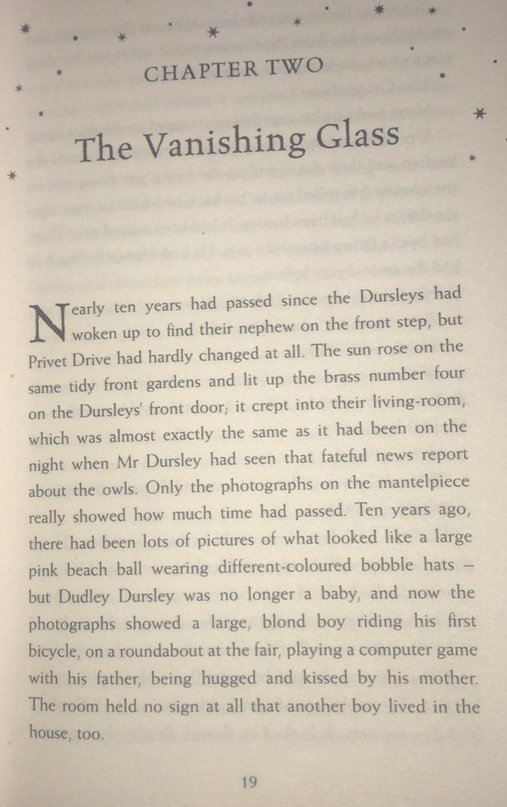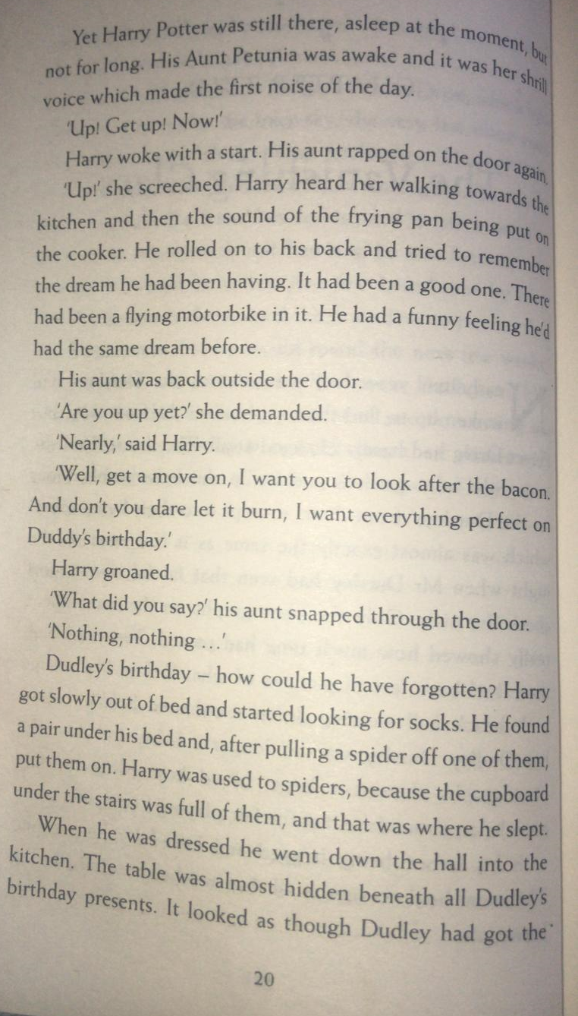
Questions
- What was the Dursley’s door sign made of?
- What is Dudley Dursley the baby compared to?
- Find and copy the three synonyms on page 20 for said that show Aunt Petunia was annoyed.
- What did Harry pull off his socks?

After reading pages 19 and 20, complete the Venn diagram for the characters Harry Potter and Dudley Dursley.
The adjectives you write could be used to described their appearance, personality. Any words that are appropriate for both Dursley and Harry go in the middle of the Venn diagram (for example, the noun – ‘boy’).

Once you have completed your Venn diagram, write at least two comparative sentences using whereas/unlike, both/similar to.
Examples:
Mr Brownsell prefers playing football, whereas Mr Wallis enjoys cricket.
Unlike Mr Wallis and Mr Brownsell, who have no pets, Miss Petty has a dog called Rico.

Both Mr Wallis and Miss Petty enjoy going to the gym to keep fit.
Mr Brownsell is similar to Mr Wallis, because he loves eating!
Venn Diagram
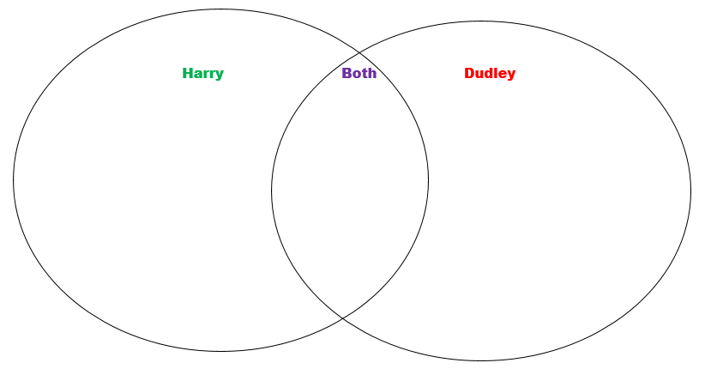

If your adults at home give you permission!
https://www.youtube.com/watch?v=GHXSvCMpCGM
Watch this clip from the film version of Harry Potter. What do you notice is the same and different in this scene to the book? Think about the Setting (what the house looks like) and the Characters.
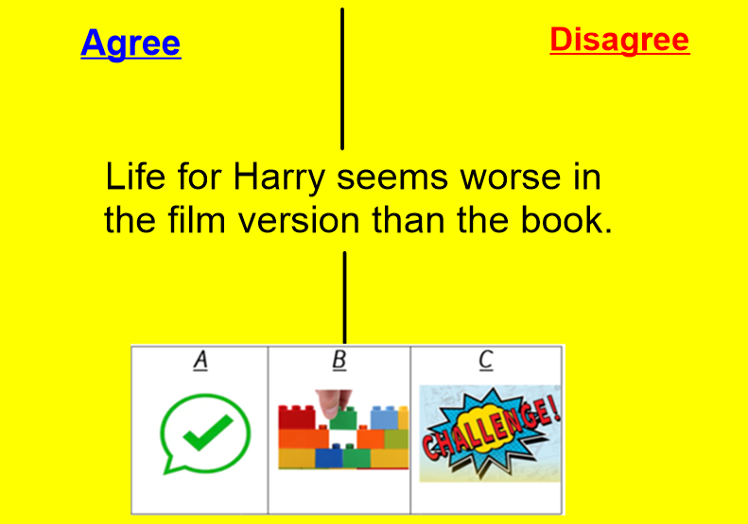
Consider reasons why you agree and disagree with the statement
Upload your thoughts on Google Classroom, either by video, photos of your work on paper or written messages.
Let’s get debating!

