Morning Maths
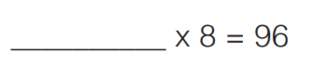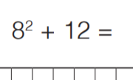
8 is the same as $\frac{8}{1}$
So do $\frac{1}{5}$ x $\frac{8}{1}$
8 x 1 =
5 x 1 =
fraction =
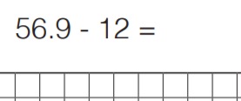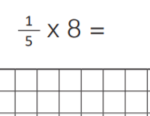

Main activity – Adding decimals to make 1
Example
What would you add to 0.26 to make 1 whole?
Method 1 – you could use your knowledge of place value and fractions.

0.26 = $\frac{26}{100}$ What do I need to add to that to make a whole ($\frac{100}{100}$)?
26 add what makes 100?
26 + 4 = 30
30 + 70 = 100
so
26 + 74 = 100
0.26 +0.74 = 1

Method 2 – use a number line
Start at 0.26 then jump to the next tenth. Then jump to the whole.
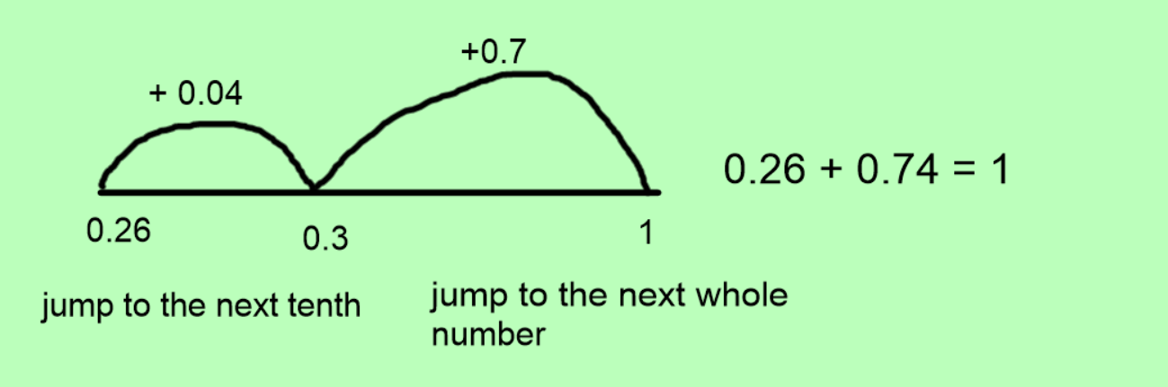

Your turn – have a go at these.
- 0.67 + _ = 1
- 0.24 + _ = 1
- 0.81 + _ = 1
- 0.12 + _ = 1
- 0.59 + _ = 1
- 0.01 + _ = 1
Challenges
