Morning Maths
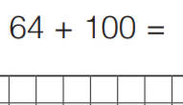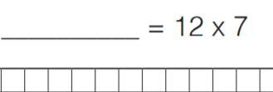
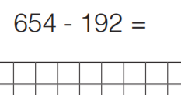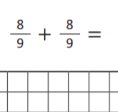
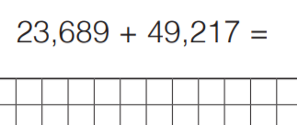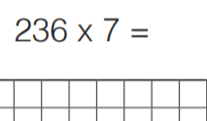

Main Activity – Rounding decimals
When rounding decimals to the nearest whole number, it means round it to the “ones” column.
Use a place value grid to help you or use a number line.
Example:
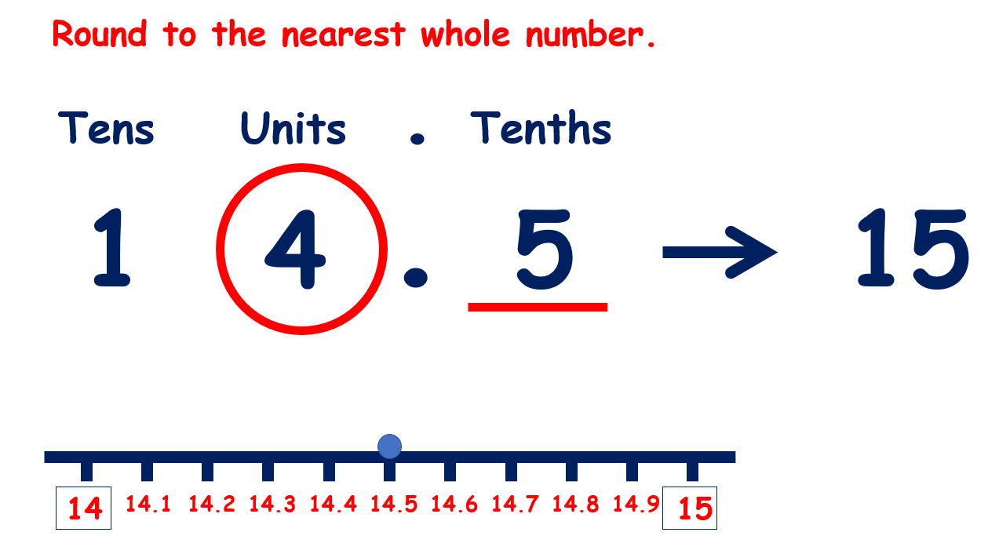
Write the place value grid. Circle the column you are rounding to – “ones” column.
Everything to the left stays the same. The tenths column tells you whether to round up or keep it the same.
5 or more – raise the score (round it up)
4 or less – let it rest (keep it the same)

Your turn – round these to the nearest whole number
- 16.3
- 23.6
- 41.8
- 53.4
- 13.9
To round to the nearest tenth, you need to circle the tenths column.
Everything to the left still stays the same. The hundredths column tell you what to round the tenths column to.
Example:
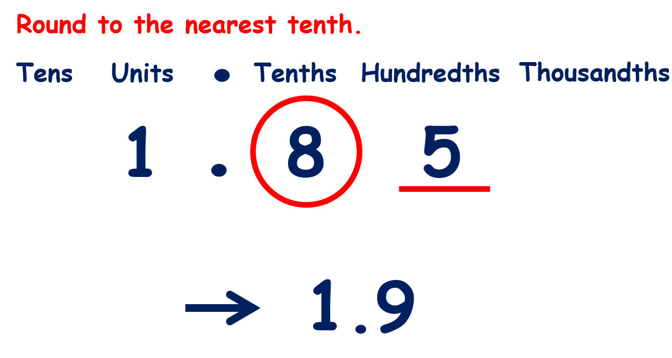

Your turn – round these to the nearest tenth
- 1.57
- 4.62
- 5.69
- 17.52
- 15.06
- 18.91
- 36.97
Round these decimals to the nearest whole and the nearest tenth
- 13.75
- 10.92
- 16.09
- 18.99

