**Morning Maths**

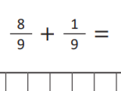 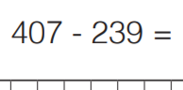

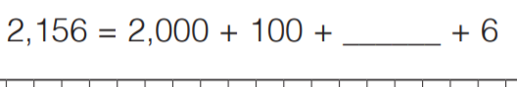

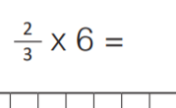 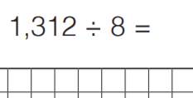

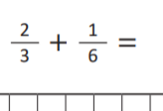 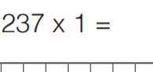

**Main problem solving activity**

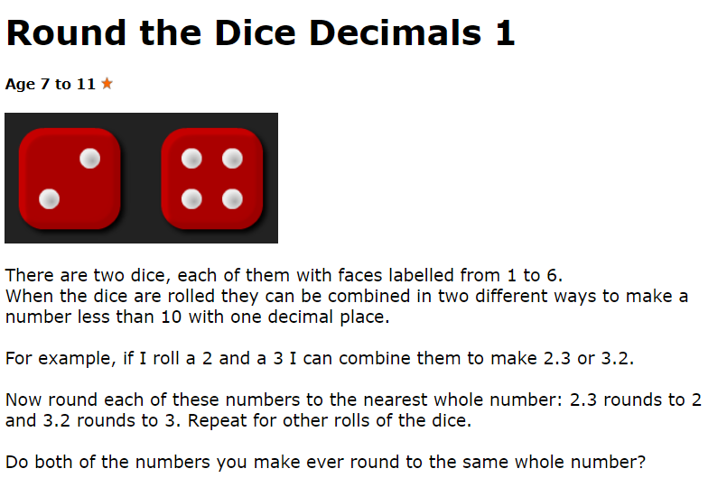

You can use an interactive dice here:

<https://nrich.maths.org/6717>

or

<https://www.online-stopwatch.com/chance-games/roll-a-dice/>