Morning maths
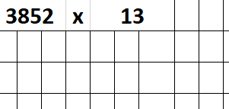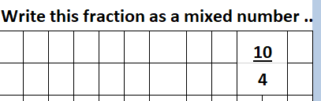
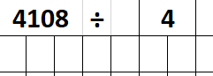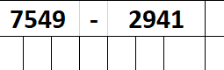
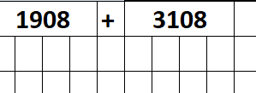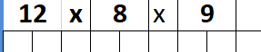
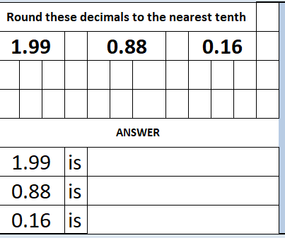

Main Task – Adding and subtracting decimals
Remember to line up the digits in the correct place value columns and to use a zero place holder if necessary.
- 23.1 – 2.78 =
- 83 – 9.2 =
- 12.9 + 8.81=
- 23.07 + 12.96 =
- 71.2 – 12.96 =

Word problems
- Peter cuts a piece of string into three lengths. One is 4.26cm long, one is 7.54cm long and the third is 3.90cm long. How long was the string before it was cut?

- I have three bags of sweets. One weighs 64.17g, one weighs 58.29g and the third weighs 68.47g. How much do they weigh altogether?

- Bill, Sarah and Joshua each have full drinks bottles. Bill bottle contains 33ml, Sarah bottle contains 55ml and Joshua’s bottle contains ¼ of a litre. How much drink do they have altogether?
You will need to know how many ml in ¼ of a litre
- Allan runs 7.7km on Monday, 6.5km on Tuesday and 9.35km on Wednesday. Find the total of his runs.

- Mrs. Warburton went on a diet. In week one she lost 2.5kg, in week two she lost 1.75kg, in week three she lost 2.75kg and in week four she got fed up, ate lots of chocolate and gained 0.66kg. How much did she lose altogether?

