Prediction
We are going to be focusing on a new text for English.
What could that text be about?
Use the clues below to make predictions about the new text.
What could the text be about and what makes you think that?
Remember to use modal verbs (could, would, might, will, should) and to support your ideas with evidence. Random ideas are no good; they have to be likely or certain given the evidence in the clues. Use conjunctions to link your ideas.

Clue - 1
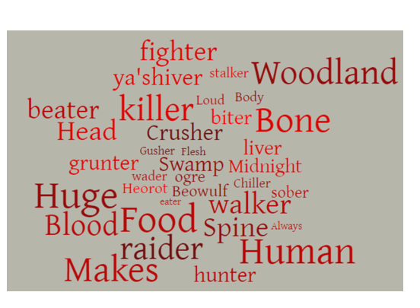

Clue – 2
