Science
Thursday 7th May 2020

Materials – Zoom In, Zoom Out
Use your knowledge about materials to try to predict what the following object is. Make a prediction at each stage explaining why.
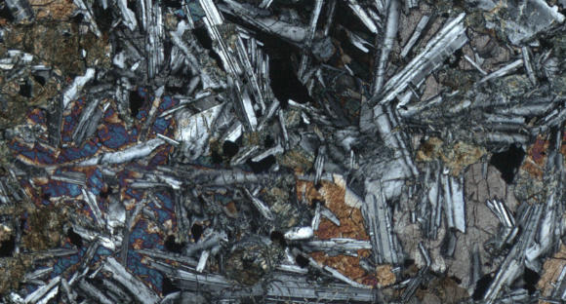
I predict…

I predict…

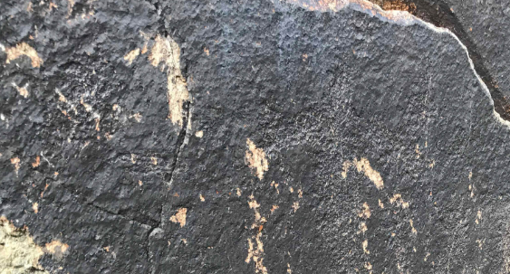
I predict…

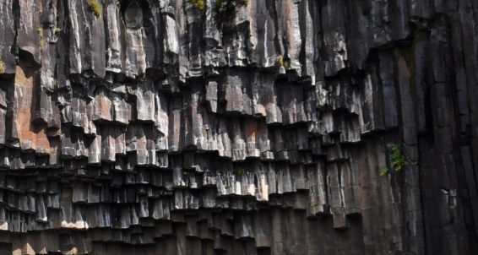
I predict…

ANSWER ON THE NEXT PAGE…NO CHEATING!

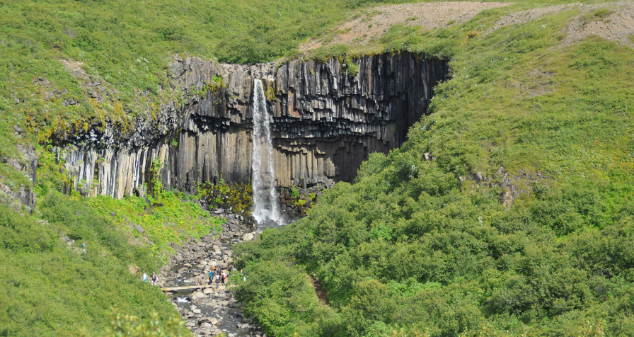

What is dissolving?
Watch the following clip to find out all about the process of dissolving.
https://www.bbc.co.uk/bitesize/topics/zcvv4wx/articles/zpbdpbk

Activity
This activity works best in clear cups/glass.
- You need to find as many solids in your house to put into glasses of water. E.g., flour, salt, sand, soil, baking soda, sugar, rice etc.
- Make a prediction in the table below before filling your glasses.
- Fill each glass with the same amount of water. Add in to each separate glass the solid (to make it a fair test use the same amount e.g. 1 teaspoon/tablespoon)
- Observe if the solid is soluble or insoluble (does it dissolve or not)
- Complete the rest of the table.

Solid Used | Prediction  Will it dissolve or not? | Soluble or Insoluble?

Were your predictions correct? Did any results surprise you?

