Science W/C 11.5.20
Please watch this video to help recap your knowledge of solids, liquids and gases (states of matter)
https://www.youtube.com/watch?v=RuP5FmFcPmY
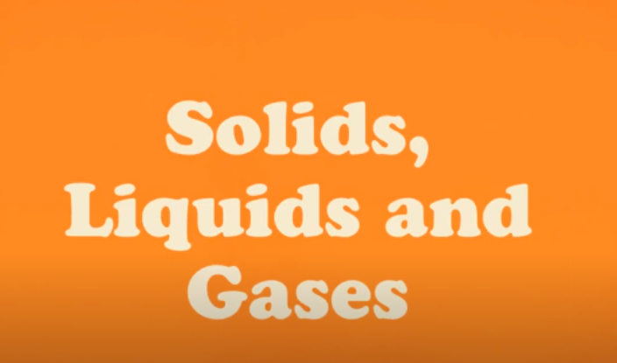
Please complete the work below.

How are the particles different in a solid, a liquid and a gas?
Match the picture to the phrase.
Solid
The particles in a solid are tightly packed and in a regular pattern. | 4 | 1 | 2 | 3
They vibrate and are held together with strong bonds.
The solid cannot change shape.
You cannot squash a solid.
Liquid |  | 4 | 5 | 6
The particles in a liquid are not so tightly packed.
They can move past each other.
The liquid changes shape to fit its container. |  | 7 | 8 | 9
You cannot squash a liquid.
Gas
The particles in a gas are widely spaced.
They can move freely. |  | 10 | 11 | 12
The gas fills its container.
You can squash a gas.

Write sentences about the different states of matter using the tables below:

The molecules in a | solid | are | tightly packed | and can | only vibrate.
 | liquid |  | further apart |  | move past each other.
 | gas |  | widely spaced |  | move freely.

A solid | can | change shape | and | it | can | be squashed.
A liquid
 | cannot | flow | but |  | cannot
A gas

Put the words below in the correct order to make sentences about states of matter:
a becomes . When it melts a solid , liquid
1.

……………………………………………………………………………………….
2.
becomes a , it When a solid . liquid freezes

……………………………………………………………………………………….

