Shadow experiment.
Look at the website https://www.dkfindout.com/uk/science/light/shadows/ and the shadow power point.

You will need:- torch, a ruler, and an object. If you do not have these, please don’t worry. Have a look at the power point and you should be able to complete the activity without.

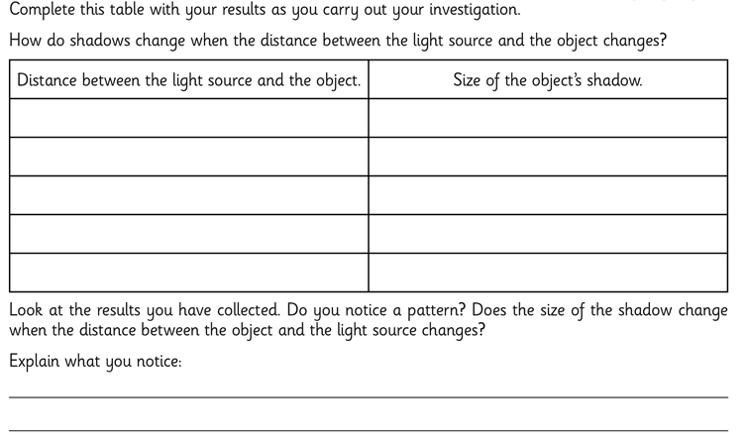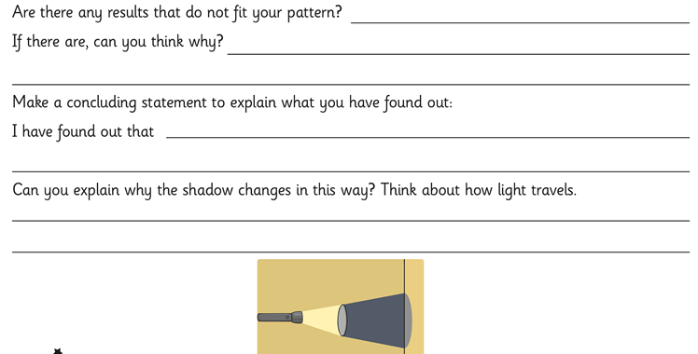
Now create a non chronolgical report or a leflet to include all of the learning you have done about light.

